WPA – Artistic Pool Division

World Championship

2018

Official Shot / Challenge Program

Shot Program and Selection
- For each degree of difficulty (DOD; point value) in each discipline, players will select one shot (a, b, or, c). Therefore, players will select 5 shots in each discipline and shoot a total of 40 shots.
- Players are locked into the selection once they take a legitimate stroke at the shot. Warm up strokes and accidentally nudging a ball with the cue tip do not constitute a legitimate stroke.
- Players will receive three attempts to make each shot. Players may only make each shot once.
- Scoring: players will receive the full DOD value if the shot is made on the first attempt, the DOD value minus one if the shot is made on the second attempt, the DOD value minus two if the shot is made on the third attempt, or zero if the shot is not made on any attempt. Exception: Shots with special scoring, as outlined in the shot program. (Discipline 2 – Shot 4; see scoresheet)

Tournament Format
- Players will be divided into ‘flights’ of 2, 3, or 4 players, depending on the number of total entrants and tables available. Flights will be determined at the players meeting or earlier. Players will be divided into groups based on ranking and flights will consist of a random selection of a player from each group.
- Each flight will play four rounds. Each round will consist of two shot disciplines grouped as follows: 1 and 2, 3 and 4, 5 and 6, and 7 and 8. The order of the grouped disciplines is at the discretion of the tournament director.
- Before each round, players will receive a set number of minutes for practice time on the tournament table. The amount of time will be decided at the players meeting or earlier. Typical practice time is four minutes.
- Playing order will consist of a ‘rotating lead off’ process. See ‘Play Order’ below.

Standings and Tiebreakers
- Player’s total point score after shooting 40 shots will determine the final standings.
- Discipline champions will be determined based on player’s total points in a given discipline.
- If players are tied on point value for either overall ranking or discipline champion, the following tiebreakers will be used:
  - 1st attempt makes
  - 2nd attempt makes
  - 3rd attempt makes
  - 1st attempt points
  - 2nd attempt points
  - 3rd attempt points
- If players remain tied for discipline champion, the “dollar bill shot” tiebreaker will be used.

Play Order – 2 player flight
Player A | Player B

Disc. 1 - Trick/Fancy |  | Disc. 2 - Special Arts |  | Disc. 3 - Draw |  | Disc. 4 - Follow
1 | A B | 1 | B A | 1 | A B | 1 | B A
2 | B A | 2 | A B | 2 | B A | 2 | A B
3 | A B | 3 | B A | 3 | A B | 3 | B A
4 | B A | 4 | A B | 4 | B A | 4 | A B
5 | A B | 5 | B A | 5 | A B | 5 | B A

Disc. 5 – Bank/Kick |  | Disc. 6 – Stroke |  | Disc. 7 – Jump |  | Disc. 8 – Masse
1 | A B | 1 | B A | 1 | A B | 1 | B A
2 | B A | 2 | A B | 2 | B A | 2 | A B
3 | A B | 3 | B A | 3 | A B | 3 | B A
4 | B A | 4 | A B | 4 | B A | 4 | A B
5 | A B | 5 | B A | 5 | A B | 5 | B A

Play Order – 3 player flight
Player A | Player B | Player C

Disc. 1 - Trick/Fancy |  | Disc. 2 - Special Arts |  | Disc. 3 - Draw |  | Disc. 4 - Follow
1 | A B C | 1 | C A B | 1 | B C A | 1 | A B C
2 | B C A | 2 | A B C | 2 | C A B | 2 | B C A
3 | C A B | 3 | B C A | 3 | A B C | 3 | C A B
4 | A B C | 4 | C A B | 4 | B C A | 4 | A B C
5 | B C A | 5 | A B C | 5 | C A B | 5 | B C A

Disc. 5 – Bank/Kick |  | Disc. 6 – Stroke |  | Disc. 7 – Jump |  | Disc. 8 – Masse
1 | C A B | 1 | B C A | 1 | A B C | 1 | B C A
2 | A B C | 2 | C A B | 2 | B C A | 2 | C A B
3 | B C A | 3 | A B C | 3 | C A B | 3 | A B C
4 | C A B | 4 | B C A | 4 | A B C | 4 | B C A
5 | A B C | 5 | C A B | 5 | B C A | 5 | C A B

Play Order – 4 player flight
Player A | Player B | Player C | Player D

Disc. 1 - Trick/Fancy |  | Disc. 2 - Special Arts |  | Disc. 3 - Draw |  | Disc. 4 - Follow
1 | A B C D | 1 | B C D A | 1 | C D A B | 1 | D A B C
2 | B C D A | 2 | C D A B | 2 | D A B C | 2 | A B C D
3 | C D A B | 3 | D A B C | 3 | A B C D | 3 | B C D A
4 | D A B C | 4 | A B C D | 4 | B C D A | 4 | C D A B
5 | A B C D | 5 | B C D A | 5 | C D A B | 5 | D A B C

Disc. 5 – Bank/Kick |  | Disc. 6 – Stroke |  | Disc. 7 – Jump |  | Disc. 8 – Masse
1 | A B C D | 1 | B C D A | 1 | C D A B | 1 | D A B C
2 | B C D A | 2 | C D A B | 2 | D A B C | 2 | A B C D
3 | C D A B | 3 | D A B C | 3 | A B C D | 3 | B C D A
4 | D A B C | 4 | A B C D | 4 | B C D A | 4 | C D A B
5 | A B C D | 5 | B C D A | 5 | C D A B | 5 | D A B C

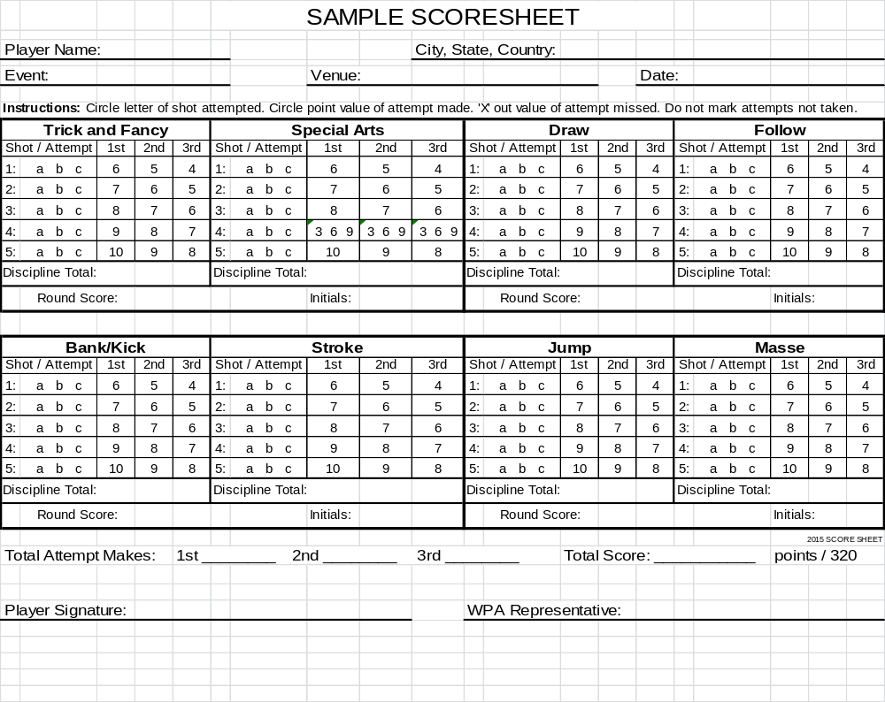
2018 WPA World Artistic Pool Championship
Playoff Score Sheet

Venue: Bogies East Date: February 8-10, 2019 Location: Houston, TX

Playoff Round: ____ MATCH WINNER: __________________LAG
CHALLENGE  INFORMATION |  |  | PLAYER A  Name:______________ |  | PLAYER B  Name:______________
Player  Order | Discipline | Shot Selection | Shot Score | Running Total | Shot Score | Running Total
A | 1
B | 2
A | 3
B | 4
A | 5
B | 6
A | 7
B | 8
A | PICK -
B
B | PICK -
A
TOTAL POINTS – EACH PLAYER |  |  | MATCH TOTAL: |  | MATCH TOTAL:
TIEBREAKER WINNER |  |  | A |  | B

SHOOT FIRST: YES _____ NO _____

WINNER: ________________________

Signature: _________________________ __________________________

Rules of Artistic Pool

General Rules
- The player is responsible for knowing the setup and requirements set forth in the shot program. All questions should be resolved prior to the match with the tournament director.
- All shots will be judged based on the intent of the shot. If any loophole is found that changes the intent of the shot, those changes to the shot will not be allowed.
- A full, intentional stroke counts as an attempt. Accidentally nudging the cue ball does not count as an attempt.
  - Exception 1: Wing shots, once a ball is rolled, it counts as an attempt.
  - Exception 2: Any shot requiring multiple hits. The first full, intentional stroke counts as an attempt. Subsequent cue contact with the cue ball or object balls count as a hit. For example, if the shot calls for the cue ball to be hit twice, nudging the cue ball on the second hit counts as a hit.
  - On shots requiring multiple hits, after the initial hit, players may take as many strokes as necessary to complete subsequent hits. For example, if the shot calls for the cue ball to be hit twice, a player attempting the second hit but completely missing the cue ball may take another stroke to try to hit the cue ball as long as other parameters of the shot are met.
- Table judge’s and tournament director’s decisions are final.

Ball and Prop Placement and Positioning
- Any balls or object specified as ‘ball-in-hand’ may be placed anywhere on the table, provided that the intent of the shot is preserved.
- Any balls or object specified as ‘ball-in-hand’ but has additional positioning requirements may be adjusted freely by the player provided that the additional requirements are met.
- All balls specified as ‘hanging near a pocket’ may be freely adjusted by the player near that pocket within reason.
- Any object or ball that must be positioned within a zone must be completely in that zone.
- Any ball that must come to rest within a zone will be considered in that zone if any part of the ball is within the zone, measured by the edge of the ball.
- All chalk cubes placed on the table must be well up, and must be square with the table (may not be rotated), unless otherwise stated.
- Chalk cubes may be positioned anywhere on the rail at the player’s discretion.
- All measurements of 1 chalk’s width will be measured with a cube of chalk held at mid-ball height (the widest part of the ball), unless otherwise stated.

Shot Allowances and Restrictions
- It is always okay for a ball to contact an extra cushion near a ball hanging in a pocket, unless otherwise stated.
- It is always okay for the cue ball to scratch, unless otherwise stated.
- If there is a helper ball – hanging ball combination, it is always okay for the cue ball to contact either the helper ball or hanging ball directly. Rules 1 and 2 still apply.
- Extra contact between balls is not allowed, unless otherwise specified.
- At no time may any ball (cue ball or object ball) or prop fly off the table.
- Players are free to shoot the mirror image of any shot. Please note that rotating a shot 90 degrees is not the mirror image and will not be allowed.
- Players are free to shoot any part of any shot with either hand.
- Players may not switch cues during a shot unless otherwise specified or due to equipment failure. Players may switch cues between attempts.
- Players must keep at least one foot on the floor when shooting. It is allowable for a player to “raise the floor” using any object.

Equipment
- All cues must be a minimum of 40 inches in length.
- Players are allowed to place chalk or other objects underneath the bridge head, or bridge butt, as needed provided those other objects do not interfere with the shot. Taping the cue tip to the chalk is not allowed.
- All vertical masse shots will require the use of a masse cloth (extra piece of standard cloth) or the Stefano Pelinga Cloth Shield.
- If a masse or break cloth is required for a shot, the player has the option of removing the extra cloth from the table during the course of the shot. If the player disturbs anything other than the cloth in this process, it will be a foul and count as a missed attempt.

DISCIPLINE

1

TRICK & FANCY SHOTS

Discipline 1 – Shot 1a – 6 points - The 3 & 3 Shot

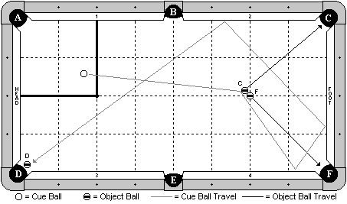

Cue Ball
In hand within the indicated zone.
Object Balls
‘C’ and ‘F’ balls frozen with ‘F’ ball on the foot spot and ‘C’ ball adjustable. ‘D’ ball hanging near pocket ‘D’.
Objective
Shoot the cue ball into ‘C’ ball. ‘C’ and ‘F’ balls will go into pockets as diagrammed. The cue ball will travel 3 cushions as diagrammed, and make ‘D’ ball.
Special Notes
None

Discipline 1 – Shot 1b – 6 points - The 2 & 2 Split Shot

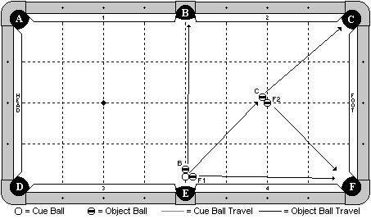

Cue Ball
In hand, within two ball widths of slate cut of pocket ‘E’.
Object Balls
‘B’ and ‘F1’ balls are in hand, frozen to the cue ball. ‘C’ and ‘F2’ balls are frozen with ‘F2’ ball on the foot spot and ‘C’ ball adjustable.
Objective
Shoot the cue ball towards ‘C’ ball. All 4 balls will go as diagrammed.
Special Notes
None.

Discipline 1 – Shot 1c – 6 points - The Swallow Shot

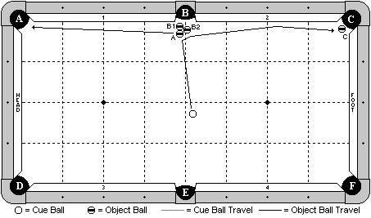

Cue Ball
In hand, behind the long center line of the table.
Object Balls
All object balls as diagrammed and adjustable.
Objective
Shoot the cue ball into ‘A’ ball. ‘A’ ball will go into pocket ‘A’. ‘B1’ will go into pocket ‘B’ by the combination with the ‘A’ ball. Cue ball will carom off and make ‘B2’ ball into pocket ‘B’. Cue ball will carom off and travel down the cushion to make ‘C’ ball.
Special Notes
None

Discipline 1 – Shot 2a – 7 points - Out of Line

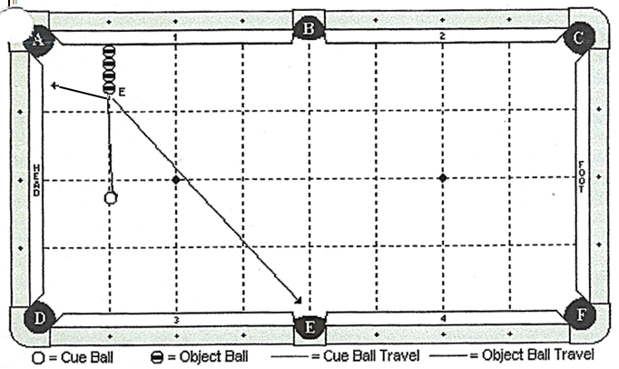

Cue Ball
In hand.
Object Balls
Four object balls are lined up on the first diamond. The first object ball is frozen to the cushion.
Objective
Shoot the cue ball into ‘E’ ball. ‘E’ ball will kiss back and go into pocket ‘E’.
Special Notes
‘E’ ball may contact cushions ‘3’ or ‘4’, but no other. Cue ball may scratch in any pocket except pocket ‘A’.

Discipline 1 – Shot 2b – 7 points - The Big ‘X’ Shot

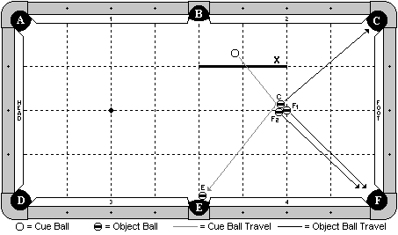

Cue Ball
In hand behind ‘X’ line.
Object Balls
A cluster of 3 balls is frozen as diagrammed, with ‘F1’ ball on the foot spot. ‘E’ ball is hanging near pocket ‘E’ and is adjustable.
Objective
Shoot the cue ball into ‘C’ ball. ‘C’ and ‘F1’ balls will go as diagrammed. The cue ball will carom off into ‘F2’ ball, making it in pocket ‘F’. The cue ball will carom off and make ‘E’ ball.
Special Notes
None

Discipline 1 – Shot 2c – 7 points - The Be Still Shot

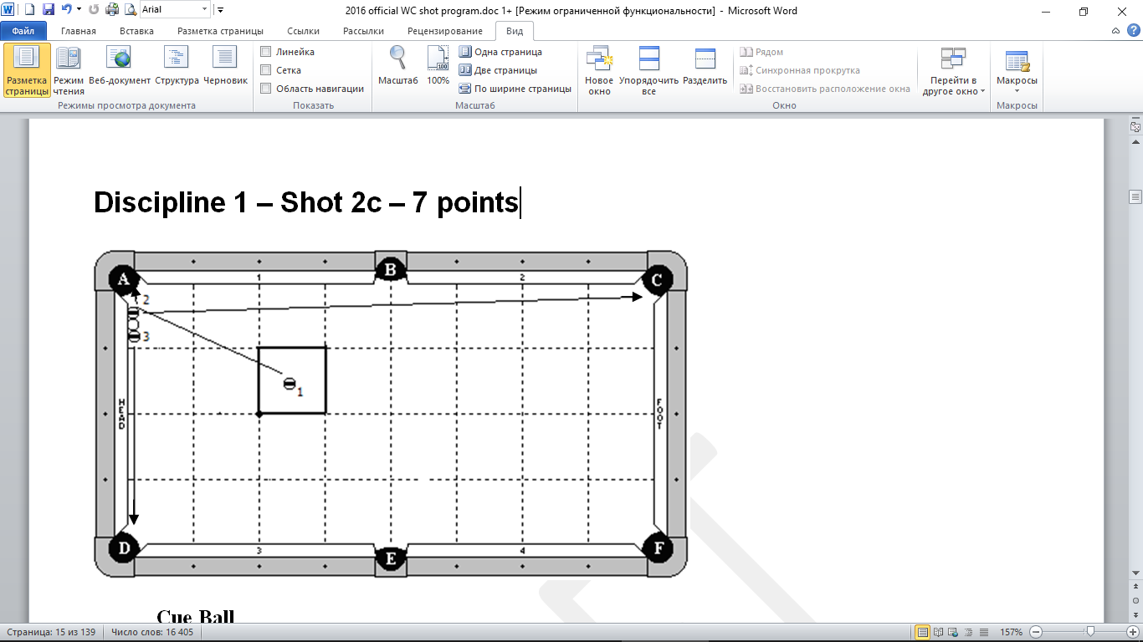

Cue Ball
Frozen to the head cushion and frozen to the 2 & 3 balls.
Object Balls
1 ball in hand within indicated zone. 2 ball frozen to the cushion and to the cue ball. 3 ball frozen to the cue ball, but does not need to be frozen to the cushion.
Objective
Shoot the 1 ball into the 2 ball. The 1 ball will go into pocket ‘A’. The 2 ball will bank into pocket ‘C’. The 3 ball will go into pocket ‘D’.
Special Notes
At the conclusion of the shot, the cue ball may not be more than 1 chalk’s width away from the head cushion.

Discipline 1 – Shot 3a – 8 points - The 4-Rail Kick Shot

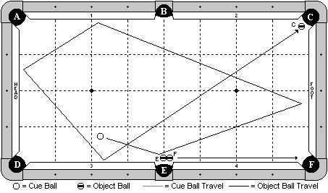

Cue Ball
In hand, at least one ball width from ‘E’ ball.
Object Balls
‘E’ and ‘F’ balls are as diagrammed and adjustable. ‘C’ ball is hanging near pocket ‘C’.
Objective
Shoot the cue ball and make ‘E’ ball in pocket ‘E’, and ‘F’ ball in pocket ‘F’. The cue ball will travel 4 cushions as diagrammed and make ‘C’ ball.
Special Notes
None

Discipline 1 – Shot 3b – 8 points - Just Showing Off Shot

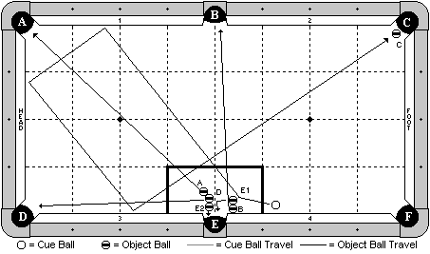

Cue Ball
In hand.
Object Balls
‘E1’ and ‘B’ balls are frozen, with ‘B’ ball also frozen to the cushion. ‘D’ ball is frozen to both ‘A’ and ‘E2’ balls. All 5 balls are adjustable within the box zone. ‘C’ ball is hanging near pocket ‘C’.
Objective
Shoot the cue ball to ‘E1’ ball. All 5 balls will go as pocket letter designates. The cue ball will travel 3 cushions to make ‘C’ ball.
Special Notes
None

Discipline 1 – Shot 3c – 8 points - The Half Butterfly

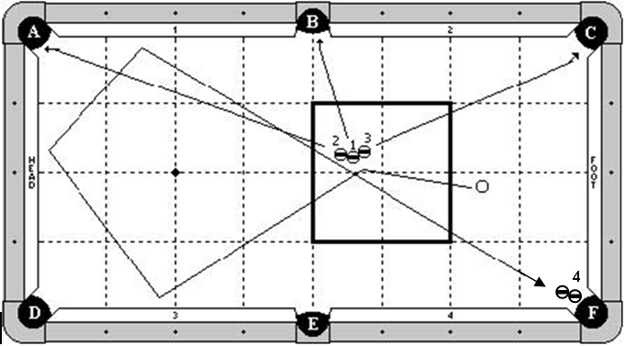

Cue Ball
In hand behind the second diamond.
Object Balls
Balls 1,2,3 are in hand as diagrammed within the indicated zone. Ball 4 combo is hanging near pocket ‘F’.
Objective
Shoot the cue ball into the 1 ball, causing the 3 balls to split as diagrammed and go into pockets A,B & C. The cue ball will travel 3 cushions as diagrammed and make the 4 ball in pocket F.
Special Notes
None.

Discipline 1 – Shot 4a – 9 points - The Tricky Cluster

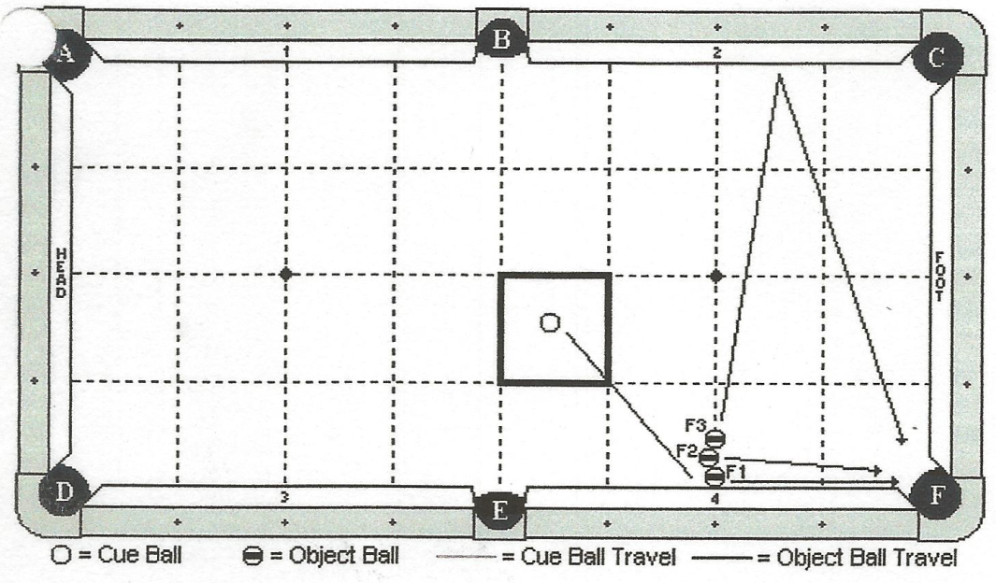
Cue Ball
In hand within box zone.
Object Balls
‘F1’ ball is frozen to cushion 4. ‘F2’ ball is in hand, frozen to ‘F1’ ball. ‘F3’ ball is in hand, frozen to ‘F2’ ball.
Objective
Shoot the cue ball into ‘F1’ ball. All three balls will go into pocket ‘F as diagram indicates.
Special Notes
All three balls may be shifted along cushion 4 at the discretion of the player. Scratch is allowed (no penalty).

Discipline 1 – Shot 4b – 9 points - The Pinball Shot

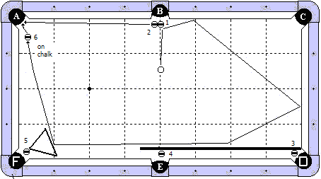

Cue Ball
In hand, behind the 1st diamond line from pocket ‘B’.
Object Balls
1 & 2 balls near pocket ‘B’. 3 ball near pocket ‘D’, frozen to the butt end of the cue stick. 4 ball near pocket ‘E’, frozen to the cue stick. 5 ball near pocket ‘F’ with a rack positioned as diagrammed. 6 ball in hand near pocket ‘A’, balanced on a piece of new chalk (well up).
Objective
Shoot the cue ball into the 1 ball. The 1 ball will go in pocket ‘B’ and the 2 ball will go in pocket ‘A’. The cue ball will travel the indicated path, hit the cue stick, causing the 3 and 4 balls to be made in their corresponding pockets. The cue ball will then hit the rack, making the 5 ball, and then hit the 6 ball, knock it off the chalk, and make it in pocket ‘A’.
Special Notes
The cue ball may hit the long cushion before hitting the rack. The 6 ball must be knocked off the chalk by the cue ball. Players selecting this shot will be required to provide the cue stick. If the cue ball jumps over the cue stick and is trapped between the cue stick and rail, the shot is no good.

Discipline 1 – Shot 4c – 9 points - The Neverending Story

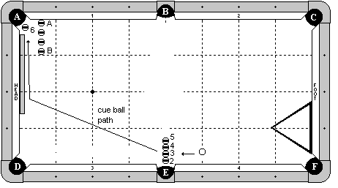

Cue Ball
In hand, on or behind the 3rd diamond line.
Object Balls
Balls 2,3,4,5 are frozen and adjustable. 6 ball is hanging near pocket ‘A’. 4 blocking balls are along the ½ diamond line, with the first (‘A’) ball frozen to the cushion and 1 ball gaps between the others. A rack is frozen to the foot cushion as diagrammed and adjustable. A cue stick butt is frozen to the head cushion and adjustable.
Objective
Shoot the cue ball into the line of balls. The 2 ball will go into pocket ‘E’, the 3 ball into pocket ‘D’, the 4 ball will bank into pocket ‘F’, and the 5 ball will go into pocket ‘B’. The cue ball will follow down table, optionally hitting the long cushion, hit the cue stick butt, and make the 6 ball.
Special Notes
The cue ball may not contact any of the blocking balls until after the 6 ball is made. Players selecting this shot will be required to supply the cue stick butt.

Discipline 1 – Shot 5a – 10 points - The Purr-fect Setup

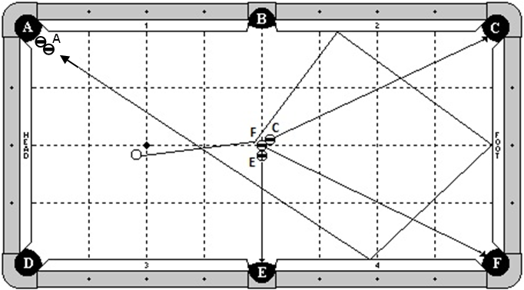

Cue Ball
In hand behind the head string.
Object Balls
‘F’ ball is exactly in the center of the table. C and E balls are frozen to ball F and adjustable. A ball combo is at pocket A.
Objective
Shooting the cue ball to F ball, make all 3 balls as pocket letters designate. The cue ball will then travel 3 rails as diagrammed and make A ball combo.
Special Notes
None.

Discipline 1 – Shot 5b – 10 points - The 2-Rail Carom Shot

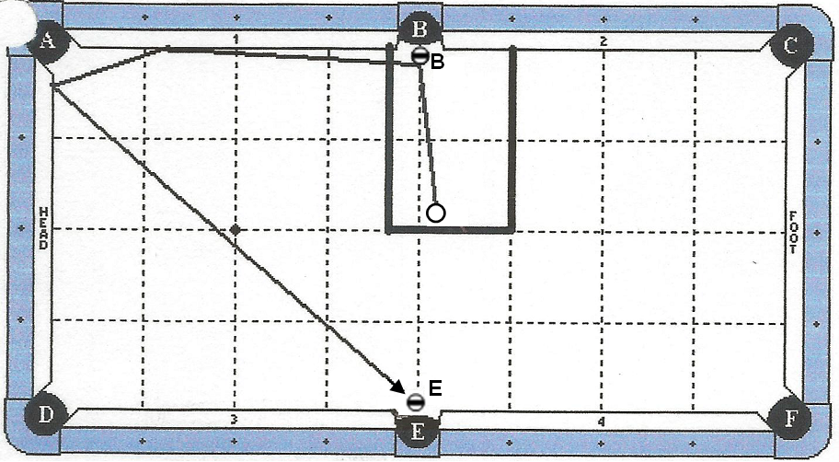

Cue Ball
In hand within box zone.
Object Balls
Object balls are hanging by pockets indicated by diagram.
Objective
Pocket ‘B’ ball into pocket B. Cue ball travels 2 cushions as diagram indicates, making ‘E’ ball in pocket E.
Special Notes
Scratch is allowed. Cue ball may contact extra cushion near pocket E.

Discipline 1 – Shot 5c – 10 points - The Hood Variation

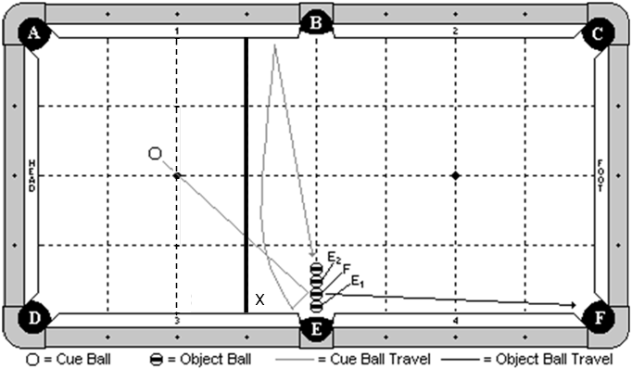

Cue Ball
In hand behind 3rd diamond line, as indicated by line X.
Object Balls
All four object balls are in a straight line, parallel to the head and foot cushions. The object ball closest to pocket E ('E1') has its edge even with the edge of the cushion. All four object balls can be moved to left or right side of the side pocket.
Objective
Shoot cue ball to 'F' ball. 'F' ball will make in pocket 'F' and 'E1' ball will make in pocket 'E'. Cue ball will contact cushion 3, bank across to cushion 1, and come back, making the two ball combination ('E2' ball will make in pocket 'E'). The ball closest to the center of the table does not have to be made.
Special Notes
The ‘F’ ball and ‘E1’ ball can have a small gap no bigger than a ball’s width. The object ball closest to the side pocket ('E1') cannot be more than a ball away from the pocket.

DISCIPLINE

2

SPECIAL ARTS

Discipline 2 – Shot 1a – 6 points - The Speed Demon

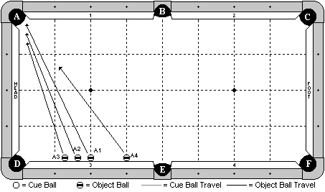

Cue Ball
None
Object Balls
4 balls are placed frozen to cushion 3 as diagrammed. ‘A4’ ball is on the 3rd diamond line. ‘A1’ ball is on the 2nd diamond line. ‘A1’, ‘A2’ and ‘A3’ balls are spaced with 1 ball gaps between them.
Objective
Shoot ‘A4’ ball towards pocket ‘A’. Quickly shoot balls ‘A1’, ‘A2’, and ‘A3’ in order into pocket ‘A’. The balls will go into pocket ‘A’ in numerical order as indicated by their ball number.
Special Notes
It is recommended that players use balls in numerical sequence for this shot. It is okay for the balls to contact each other as they are rolling, provided that they go into the pocket in the following order: ‘A1’, ‘A2’, ‘A3’, ‘A4’.

Discipline 2 – Shot 1b – 6 points - Beat The ‘1’

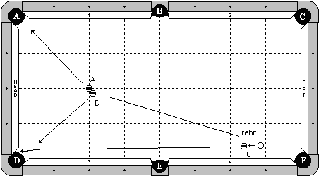

Cue Ball
In hand behind the 2nd diamond line.
Object Balls
8 ball in hand behind the 2nd diamond line. ‘A’ ball on the head spot. ‘D’ ball frozen to ‘A’ ball and adjustable.
Objective
Shoot the cue ball into the 8 ball. Re-hit the cue ball into ‘D’ ball, causing the ‘D’ and ‘A’ ball to be made as pocket letter designates. The 8 ball will go into pocket ‘D’ after ‘D’ ball, no additional contact by object balls are allowed.
Special Notes
The 8-ball must go into pocket D without an additional hit by the cue ball.

Discipline 2 – Shot 1c – 6 points - The Phantom Shot

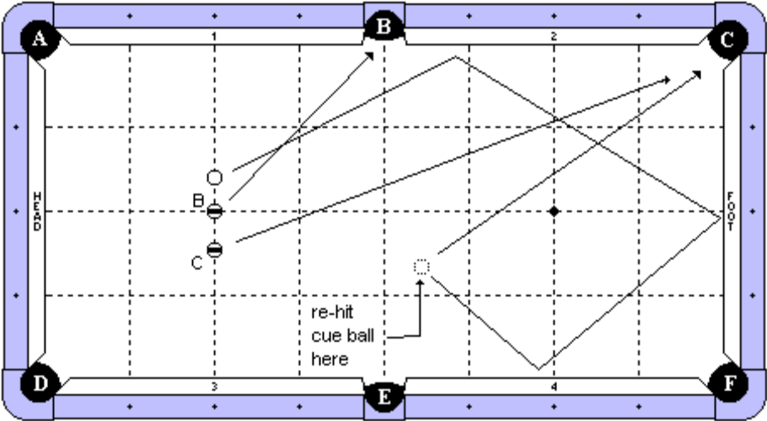

Cue Ball
In hand, on head string, to the left of ‘B’ ball.
Object Ball
‘B’ ball on head spot.
‘C’ ball in hand on head string to the right of ‘B’ ball.
Objective
Hit the cue ball first. It will travel three rails approximately to the marked point. While the cue ball is rolling, shoot ‘B’ ball into pocket ‘B’. Then shoot ‘C’ ball towards pocket ‘C’. Re-hit cue ball into pocket ‘C’. The cue ball must go in to pocket ‘C’ before ‘C’ ball.
Special Notes
The cue ball must be rolling when hit a second time.
The cue ball may hit on either side of pocket ‘B’ for the first rail.

Discipline 2 – Shot 2a – 7 points - Massey’s Over, Around, & Under

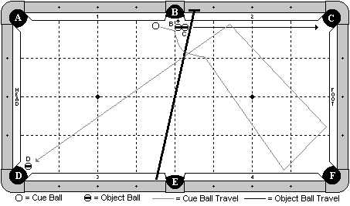

Cue Ball
In hand
Object Balls
‘B’ and ‘C’ balls frozen near pocket ‘B’ and adjustable. ‘D’ ball hanging near pocket ‘D’. The bridge is on the rail tops, with the head of the bridge near pocket ‘B’. The player has the option to prop up the butt end of the bridge with a chalk cube.
Objective
Shoot the cue ball into ‘B’ ball. ‘B’ and ‘C’ balls will go as pocket letter designates. The cue ball will jump over the bridge, travel three cushions as diagrammed, and make ‘D’ ball.
Special Notes
The cue ball may hit the bridge.

Discipline 2 – Shot 2b – 7 points - Precise Timing

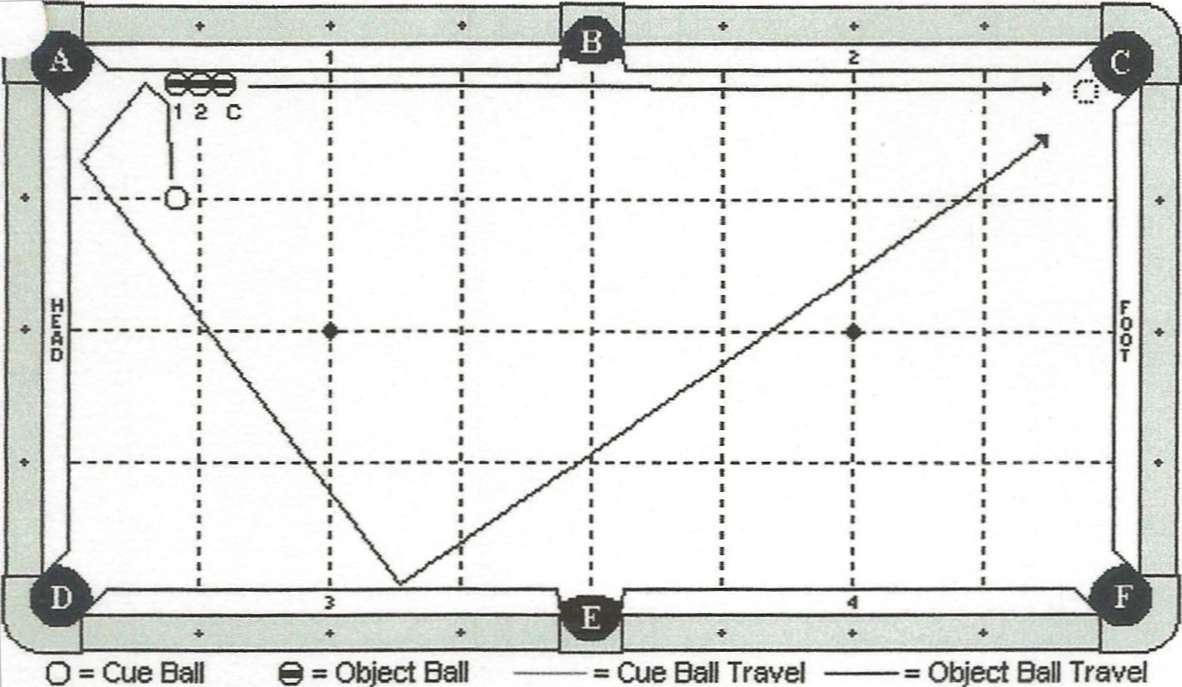

Cue Ball
On 1st diamond line, exactly across from object ‘1’.
Object Balls
All three balls frozen to cushion 1, with middle ball (‘2’) 1 diamond segment from pocket ‘A’.
Objective
Shoot the cue ball to object ball ‘1’. ‘C’ ball will roll down the rail towards pocket ‘C’. The cue ball will travel 3 cushions as the diagram indicates and make contact with ‘C’ ball, knocking it into pocket ‘C’.
Special Notes
None.

Discipline 2 – Shot 2c – 7 points - Hide ‘N’ Seek

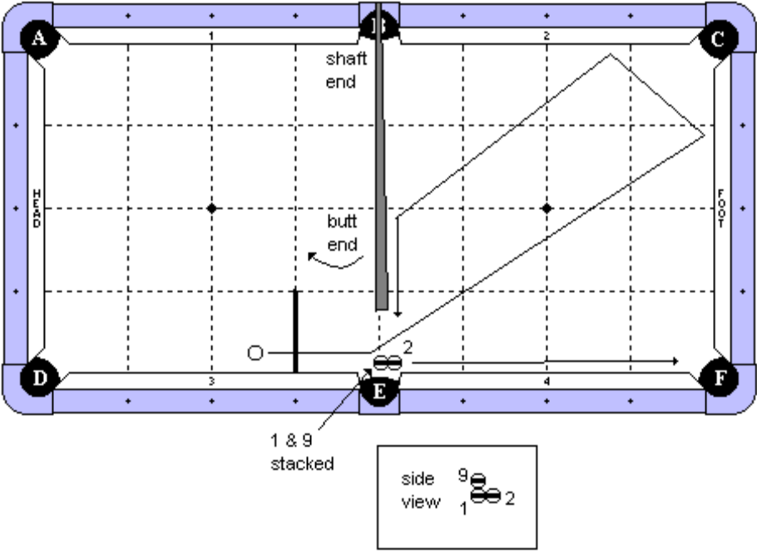

Cue Ball
In hand behind 3rd diamond line, as indicated.
Object Balls
The 1 ball is a special stacking ball near pocket E. The 2 ball is frozen to the 1 ball. The 9 ball is balanced on top of the 1 ball.
Props
A regular cue stick is laying with the tip end balanced on the rail top. The cue stick must cross the rail within one half diamond or be on top of pocket ‘B’. The butt end of the cue stick may not be closer than 4 ball’s width to the setup.
Objective
Shoot the cue ball into the 1 ball. The 1 ball will go into pocket E and the 2 ball will go into pocket F. The cue ball will travel 2 cushions, hit the stick, and make the 9 ball.
Special Notes
None.

Discipline 2 – Shot 3a – 8 points - Jacked Up Spot Shot

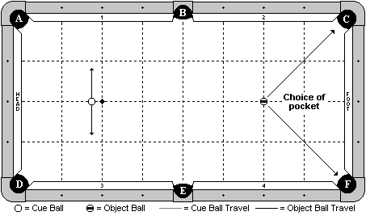

Cue Ball
In hand behind the 2nd diamond.
Object Balls
On foot spot.
Objective
Shoot the cue ball one handed, jacked up (no rail or bridge allowed), and make the object ball in either pocket ‘C’ or ‘F’ (player’s choice).
Special Notes
Unless obvious from the placement, the player must designate which pocket the object ball will go into.

Discipline 2 – Shot 3b – 8 points - The Over & Under Shot

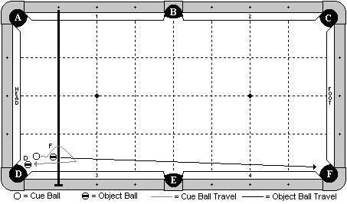

Cue Ball
In hand within 1x1 diamond zone near pocket ‘D’.
Object Balls
‘F’ ball in hand within 1x1 diamond zone near pocket ‘D’. ‘D’ ball hanging near pocket. Bridge is on the rail top along the 1st diamond. Players have the option of propping up the bridge with any object.
Objective
Shoot the cue ball into ‘F’ ball, making it in pocket ‘F’. The cue ball will jump over the bridge, and draw back under it, to make ‘D’ ball.
Special Notes
The bridge may be contacted without penalty. The cue ball may contact cushion 3 or the head cushion prior to making ‘D’ ball, but no other cushion.

Discipline 2 – Shot 3c – 8 points - The Easy Button Shot

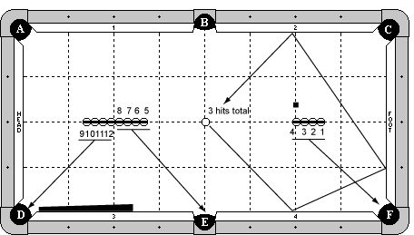

Cue Ball
On center spot.
Object Balls
1-4 balls frozen on center line with 4B on spot. 5-8 balls frozen on center line. 9-12 balls frozen on center line. 8B and 12B frozen, splitting the spot. Cue stick butt frozen to cushion 3. A piece of chalk is on the foot string, even with the 4B and 1 ball's width away.
Objective
Shoot CB around the chalk. Shoot 1,2,3,4 balls into pocket F in order. Re-hit CB around the chalk. Shoot 5,6,7,8 balls into pocket E in order. Re-hit CB around chalk so it will eventually go into pocket D. Shoot 9-12 balls into pocket D in order before CB gets there.
Special Notes
Only CB may hit cue stick butt. Chalk may not be contacted by any means. CB may never stop. No balls may be disturbed except the ball being shot. Balls will be pocketed in the following order: 1-12,CB. Balls may not hang up and be made by the next ball.
There is no requirement to shoot any balls left-handed, however, the player may do so at their own discretion.

Discipline 2 – Shot 4a – 9 points maximum - Wing Shots

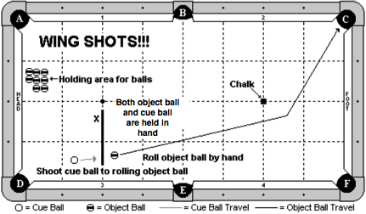

Cue Ball
Starts in the player’s hand.
Object Balls
Object balls start on the table as diagrammed. There are a total of 9 object balls on the table – 1 in hand and 8 in the holding area. Player will start with one object ball and place it in their hand along with the cue ball. A chalk cube is aligned as diagrammed and placed on the foot spot.
Objective
Roll the object ball down the table as diagrammed. Position the cue ball behind the head string. Shoot the cue ball into the rolling object ball and make it in pocket ‘C’. Repeat with 2 more object balls. Note: An attempt consists of 3 wing shots.
Special Notes
The object ball must be rolling when hit by the cue ball. The object ball must be hit by the cue ball before it hits the foot cushion. No abort rolls. The chalk may not be hit by the object ball. Use of a guide when rolling the object ball is not allowed.
Special Scoring (per attempt)
Make 1 wing shot: 3 points
Make 2 wing shots: 6 points
Make 3 wing shots: 9 points

Players are given 3 attempts with 3 object balls for each attempt.

Note: Best score of 3 attempts will be counted for final score.

Discipline 2 – Shot 4b – 9 points maximum - The Traveling Music Shot

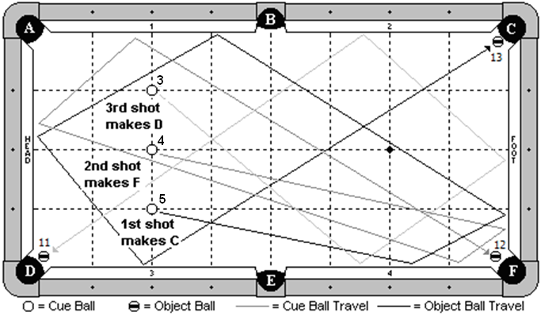

Cue Ball
None
Object Balls
Three object balls are placed on the head string, with the center ball on the head spot. It is recommended that the player use the 5,4 & 3 balls as diagrammed. Three other object balls are placed near their corresponding pockets. It is recommended that the player use the 13, 12, & 11 balls as diagrammed.
Objective
Shoot the 5 ball first, 5 cushions as diagrammed, to make the 13 ball. Shoot the 4 ball second, 4 cushions as diagrammed, to make the 12 ball. Shoot the 3 ball third, 3 cushions as diagrammed, to make the 11 ball.
Special Notes
The player will be timed on this shot. The clock will start when the 5 ball is struck and it will stop when the 3 ball is struck. Players have a maximum of 4 seconds to perform this shot.
Special Scoring
Make any 1 ball: 3 points
Make any 2 balls: 6 points
Make any 3 balls: 9 points

Players are given three attempts. The highest scoring attempt will be used.

Discipline 2 – Shot 4c – 9 points maximum - Through the Gap Shot

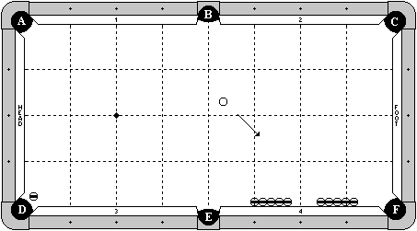

Cue Ball
In hand.
Object Balls
One object ball hanging near pocket ‘D’.
Two rows of 5 object balls are frozen against cushion 4 with exactly a 4 ball gap in between them. End balls may not be past the point of pocket ‘F’ or ‘E’.
Objective
Shoot the CB through the gap around 3 rails. Re-hit the moving CB through the gap around 3 rails. Re-hit the moving CB a second time through the gap around 3 rails. Re-hit the moving CB a third time through the gap and around 3 rails, making ‘D’ ball in pocket ‘D’.
Special Notes
The cue ball must be moving when it is re-hit each of the three times.
The rows of blocker balls may not be contacted by any means during the shot.
Special Scoring
First hit through the gap and CB goes three rails. No points awarded yet.
First re-hit through the gap and CB goes three rails: 3 points.
Second re-hit through the gap and CB goes three rails: 6 points.
Third re-hit through the gap, CB goes three rails, and must make of OB in pocket D: 9 points

Examples: If a player successfully re-hits the CB and goes 3 rails the first time, but misses the second time in any way, the attempt is scored as 3 points. If a player successfully re-hits the CB and goes 3 rails the 2nd time, but misses the 3rd time in any way, the attempt is scored as 6 points.

The CB must hit cushions 4, foot, and 2 for points to be awarded for the hit. Hitting the point of pocket ‘C’ such that the CB re-hits the foot cushion does not count as a successful hit. Table judge’s decision is final.

Players are given three attempts. The highest scoring attempt will be used.

Discipline 2 – Shot 5a – 10 points - Pelinga’s Jump Hook

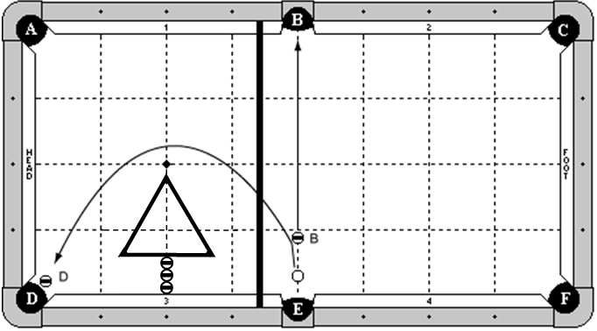

Cue Ball
In hand, but may not be more than 3 ball’s width from the long rail.
Object Balls
‘B’ ball is along the center line of the table and adjustable. ‘D’ ball is hanging near pocket ‘D’. A bridge is on the rail tops, no more than 1 diamond from pocket ‘D’. A rack is placed as diagrammed, centered on the head string, and exactly 3 balls off the cushion.
Objective
Shoot the cue ball into ‘B’ ball, making it in pocket ‘B’. The cue ball will jump over the bridge, draw around the rack, and make ‘D’ ball.
Special Notes
The cue ball may contact the bridge, but not the rack until after ‘D’ ball is made.

Discipline 2 – Shot 5b – 10 points - The Rebound Jump Follow

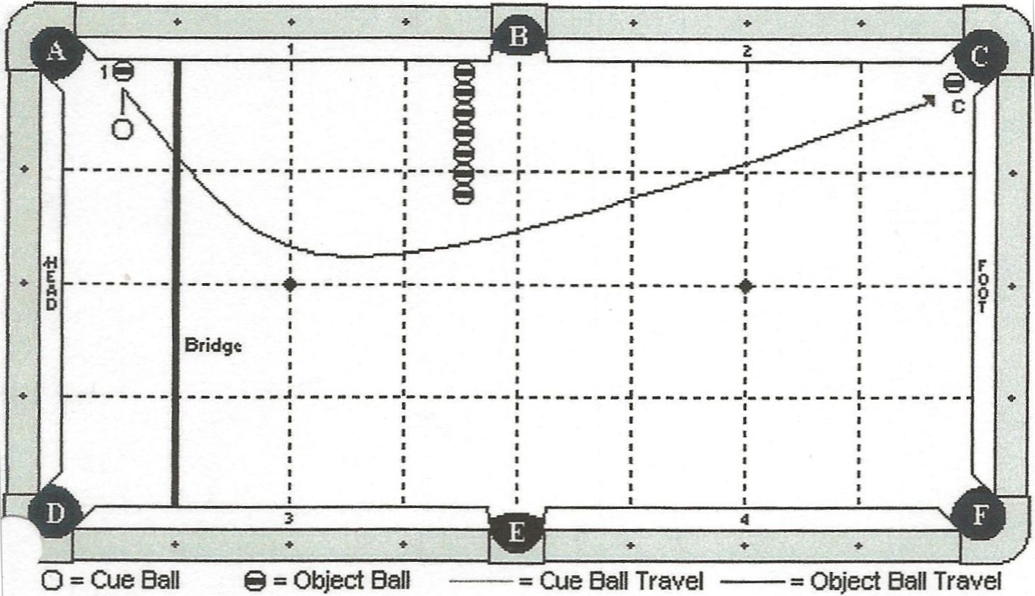

Cue Ball
In hand.
Object Balls
Object ball ‘1’ is frozen to cushion 1 and is ½ diamond segment from pocket ‘A’. ‘C’ ball is hanging. Row of 7 blocking balls are all frozen to each other with the first ball frozen to cushion 1. They make straight line ½ diamond segment from pocket ‘B’. The bridge will be placed across the table at the 1st diamond.
Objective
Shoot the cue ball into object ball ‘1’. The cue ball will jump over the bridge, curve around the blocking balls, making ‘C’ ball.
Special Notes
The row of blocking balls may not be touched by any means until after ‘C’ ball has been made. The cue ball may not contact any cushion other than the foot cushion and cushion ‘2’ until after ‘C’ ball has been made. The cue ball cannot bounce over the row of balls and make the ‘2’ ball. The ‘1’ ball can touch the bridge.

Discipline 2 – Shot 5c – 10 points - 3, 2, 1 - 1, 2, 3

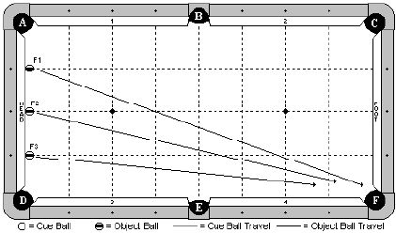

Cue Ball
None.
Object Balls
All three ‘F’ balls are placed frozen to head cushion at the diamond segments as diagram indicates.
Objective
Shoot all three balls into pocket ‘F’. ‘F3’ ball will be contacted first, followed by ‘F2, and finally ‘F1’ ball.
Special Notes
Balls may not contact each other as they are rolling down the table. It is recommended that balls in numerical order are used. Decision of the table judge is final.

DISCIPLINE

3

DRAW SHOTS

Discipline 3 – Shot 1a – 6 points - The Easy Drawback Shot

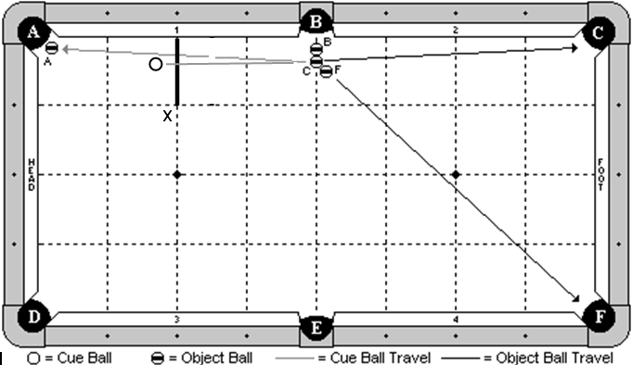

Cue Ball
In hand, behind head string as indicated by the diagram.
Object Balls
3 ball cluster is adjustable and near pocket ‘B’ as diagrammed. ‘A’ ball is hanging near pocket ‘A’
Objective
Shoot the cue ball into the middle ball of the cluster. The three balls will go as designated by pocket letter. The cue ball will draw back and make ‘A’ ball.
Special Notes
None

Discipline 3 – Shot 1b – 6 points - The Rail Draw Arc

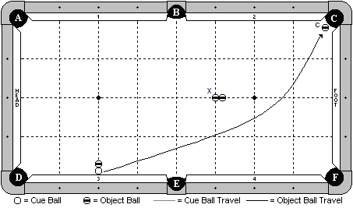

Cue Ball
Frozen to the cushion at the 2nd diamond.
Object Balls
‘C’ ball is hanging as diagrammed. A blocker ball is frozen to the cue ball on the 2nd diamond line. Two blocker balls are placed frozen on the long center line of the table, with the ball marked ‘X; on the diamond intersection line as indicated by the diagram.
Objective
Shoot the cue ball into cushion 3, causing it to escape. The cue ball will curve/draw around the blocker balls and make ‘C’ ball.
Special Notes
The three blocker balls may not move by any means until after ‘C’ ball has been made.

Discipline 3 – Shot 1c – 6 points - The Firecracker

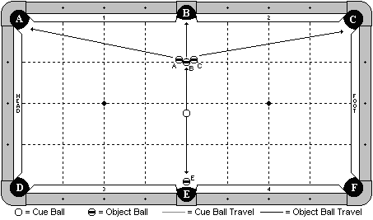

Cue Ball
In hand behind the long center line of the table.
Object Balls
‘B’ ball is on the center line and 1 diamond segment from pocket ‘B’. ‘A’ and ‘C’ balls are frozen to ‘B’ ball and adjustable. ‘E’ ball is hanging near pocket ‘E’.
Objective
Shoot the cue ball to ‘B’ ball. The cluster of 3 balls will go as pocket letter designates. The cue ball will draw back and make ‘E’ ball.
Special Notes
Scratch is allowed
Discipline 3 – Shot 2a – 7 points - Pitching a Curve Ball

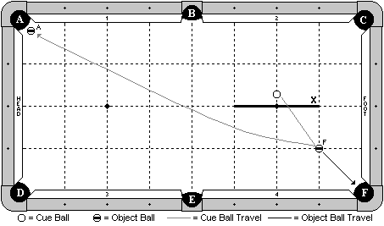

Cue Ball
In hand behind ‘X’ line.
Object Balls
‘F’ ball on the 1-1 diamond intersection line. ‘A’ ball is hanging near pocket ‘A’.
Objective
Shoot the cue ball to make ‘F’ ball in pocket ‘F’. The cue ball will draw back and make ‘A’ ball.
Special Notes
The cue ball may contact cushion 1 or the head cushion, but no other, prior to pocketing ‘A’ ball.

Discipline 3 – Shot 2b – 7 points - The Spin Transfer Shot

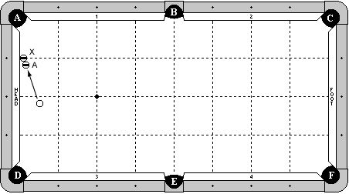

Cue Ball
In hand, behind long center line of table.
Object Balls
‘X’ ball is frozen to head cushion at the first diamond from pocket ‘A’.
‘A’ ball is frozen to ‘X’ ball, as diagrammed.
Objective
Shoot cue ball in to ‘A’ ball. ‘X’ ball will bank away. ‘A’ ball will go in to pocket ‘A’. After contact with ‘A’ ball, cue ball must draw back to contact rail 3 or 4 without hitting another cushion beforehand.
Special Notes
‘A’ ball may not be contacted by either ‘X’ ball or CB after the initial hit.

Discipline 3 – Shot 2c – 7 points - The Proposition

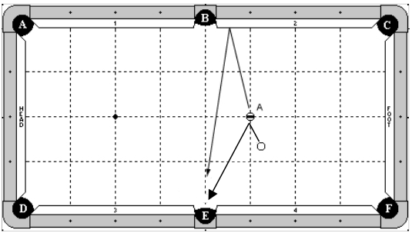

Cue Ball
In hand
Object Balls
‘A’ ball on the diamond intersection line as diagrammed.
Objective
Shoot the cue ball into ‘A’ ball, causing it to bank and make in pocket ‘E’. The cue ball will draw back and go into pocket ‘E’.
Special Notes
The cue ball must go into pocket ‘E’ first. Table judge decision is final.

Discipline 3 – Shot 3a – 8 points - The Carom Draw Shot

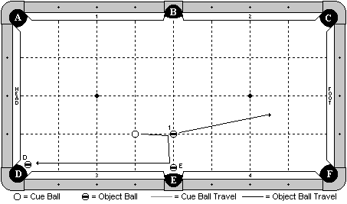

Cue Ball
In hand along the 3rd diamond line.
Object Balls
1 ball on the diamond intersection line as diagrammed. ‘E’ and ‘D’ balls are hanging near their respective pockets. ‘E’ ball may not be more than 1 ball’s width from the pocket cut.
Objective
Shoot the cue ball into the 1 ball. The cue ball will carom over and make ‘E’ ball. It will then draw back and make ‘D’ ball.
Special Notes
The 1 ball doesn’t have to be pocketed.

Discipline 3 – Shot 3b – 8 points - The Throw Shot

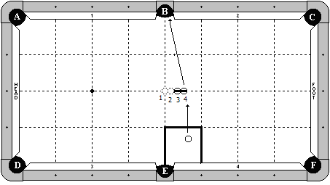

Cue Ball
In hand within the indicated zone.
Object Balls
Place 4 balls frozen in line along the center line of the table. Remove balls 1 and 2 and leave balls 3 and 4 in place.
Objective
Shoot the cue ball into the 4 ball. The 4 ball will go straight into pocket ‘B’.
Special Notes
The balls must be exactly straight. Players are not allowed to rotate the balls and adjust the tangent line towards pocket ‘B’.

On a 7-ft table, the object balls will be moved to positions 2 and 3 in the diagram. That is, there will only be a ½ ball space from the center spot of the table (as opposed to the 1-1/2 ball space in the diagram for a 9-ft table).

Discipline 3 – Shot 3c – 8 points - Szywala’s Split Draw Shot

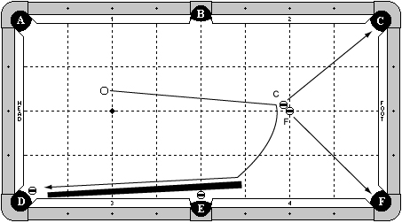

Cue Ball
In hand behind head string.
Object Balls
‘F’ ball on foot spot. ‘C’ ball in hand frozen to ‘F’ ball. An object ball is hanging in pocket ‘E’ and pocket ‘D’. A cue stick is placed frozen to ball near pocket ‘E’. The end of the butt must be more than 3 diamonds away from foot cushion.
Objective
Shoot cue ball in to ‘C’ ball causing ‘C’ ball to go in to pocket ‘C’ and ‘F’ ball to go in to pocket ‘F’. Cue ball will draw back hitting the cue stick and pocketing the hanging ball in pocket ‘E’. Cue ball will continue to draw down the rail to pocket the hanging ball in pocket ‘D’.
Special Notes
None.

Discipline 3 – Shot 4a – 9 points - The Energy Transfer Shot

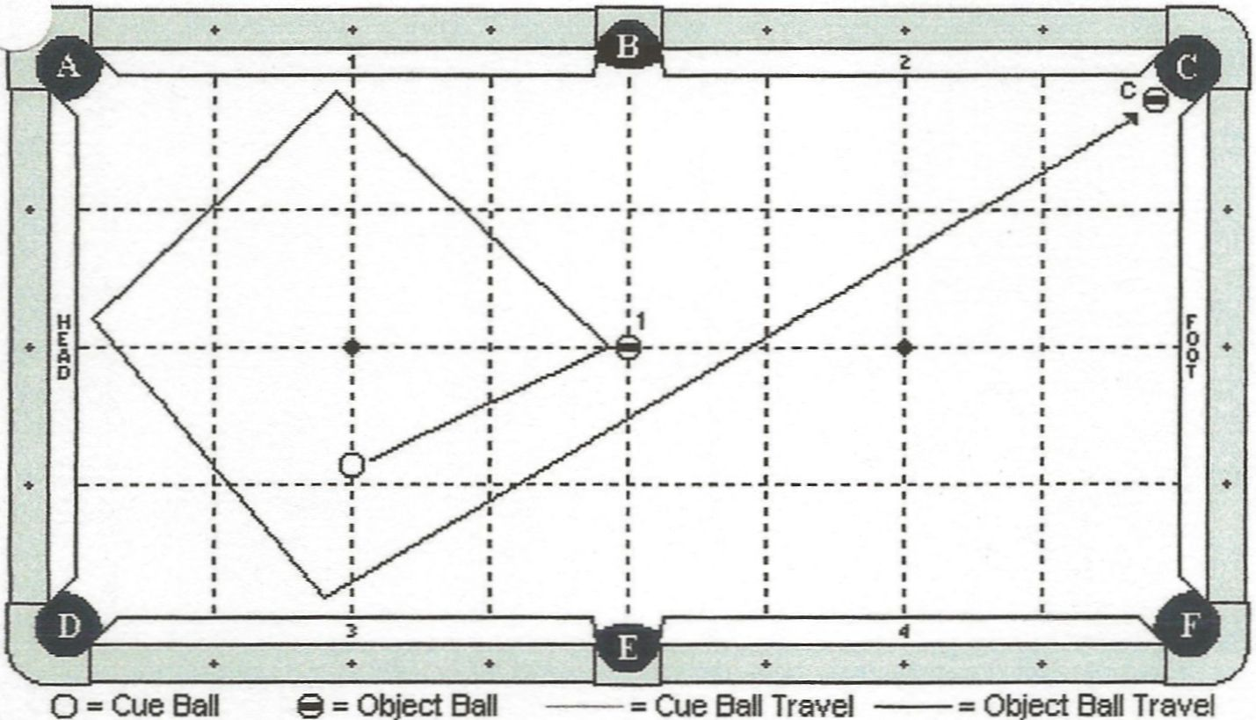

Cue Ball
In hand along head string.
Object Balls
‘1’ ball is on center spot. ‘C’ ball is hanging.
Objective
Shoot the cue ball into ‘1’ ball, drawing it three rails as diagram indicates, making ‘C’ ball.
Special Notes
Object ball ‘1’ may not contact ‘C’ ball. Object ball ‘1’ does not have to be made.

Discipline 3 – Shot 4b – 9 points - Slice ‘N’ Draw

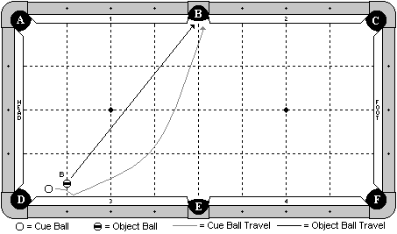

Cue Ball
In hand.
Object Balls
‘B’ ball is in hand along the 1st diamond line, but may be no more than 1 ball + 1 chalk’s width from the cushion.
Objective
Shoot the cue ball into ‘B’ ball. The cue ball will curve around the rolling ‘B’ ball. Both balls will go into pocket ‘B’, cue ball first.
Special Notes
The balls may contact each other more than once. Close calls will be at the discretion of the table judge.

Discipline 3 – Shot 4c – 9 points - The One-handed Quick Draw

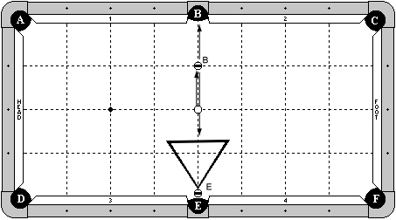

Cue Ball
On center spot.
Object Ball
‘B’ ball on center line, one diamond away from pocket ‘B’.
‘E’ ball on center line, with back edge even with pocket cut or deeper.
A rack is frozen to ‘E’ ball as diagrammed.
Objective
Shoot the cue ball one-handed, jacked up, pocketing ‘B’ ball in pocket ‘B’ and drawing the cue ball back, hitting the rack and pocketing ‘E’ ball in pocket ‘E’.
Special Notes
None.

Discipline 3 – Shot 5a – 10 points - Massey’s Power Draw

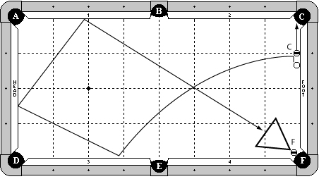

Cue Ball
In hand, frozen to the foot cushion, but must be at least 1 ball’s width from the object ball.
Object Balls
‘C’ ball frozen to the foot cushion at the 1st diamond. ‘F’ ball hanging in pocket F. A rack is in hand, frozen to ‘F’ ball.
Objective
Shoot the cue ball and make ‘C’ ball. The cue ball will draw around the table as indicated, hit the rack, and make ‘F’ ball in pocket F.
Special Notes
The cue ball may contact cushion 3 or 4 as the 1st cushion. The cue ball may contact extra cushions near pocket ‘F’. The cue ball may go between the rack and either rail and make ‘F’ ball directly.

On a 7 ft table, the rack will be replaced with an object ball making a combination that makes “F” ball.

Discipline 3 – Shot 5b – 10 points - The Circular Draw Shot

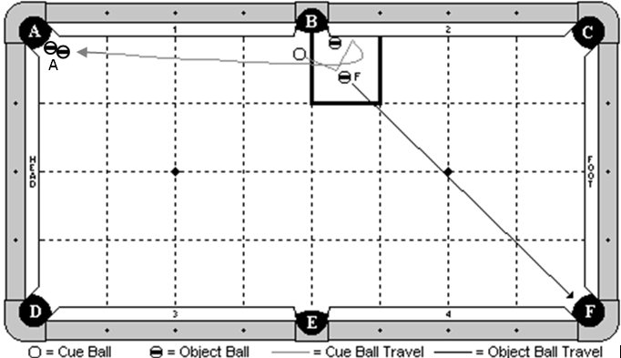

Cue Ball
In hand.
Object Balls
Blocker ball is frozen to cushion 2 with the edge aligned with the pocket point. ‘F’ ball is in hand within the indicated zone. A ball combo is hanging near pocket ‘A’.
Objective
Shoot the cue ball and make ‘F’ ball in pocket ‘F’. The cue ball will carom into cushion 2, draw around the blocker ball, and make A ball combo in pocket ‘A’.
Special Notes
The blocker ball may not be touched by any means until after ‘A’ ball is made.

Discipline 3 – Shot 5c – 10 points - Down The Alley

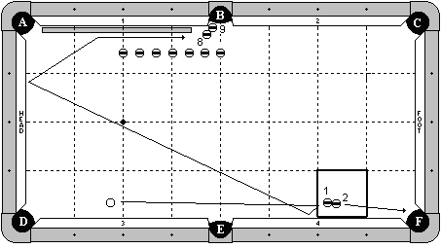

Cue Ball
In hand behind the head string.
Object Balls
The 1-2 combination is in hand within the indicated zone. The 8-9 combination is near pocket ‘B’ as diagrammed. 7 blocker balls are 3 ball’s width off the cushion. The first ball is on the 2nd diamond line, the last ball is on the center line, and the others are evenly spaced between them. A cue stick butt is frozen to cushion 1.
Objective
Shoot the cue ball and make the 2 ball in pocket ‘F’. The cue ball will draw back as diagrammed, hit the cue stick, and make the 8-9 combination.
Special Notes
The cue ball does not need to hit cushion 4. It may draw straight back into the head cushion. The blocker balls may not be disturbed by any means until after the cue ball hits the 8 ball. After the cue ball contacts the 1 ball for the first time, the 1 ball may not interfere with the shot. Players selecting this shot will be required to supply the cue stick butt.

DISCIPLINE

4

FOLLOW SHOTS

Discipline 4 – Shot 1a – 6 points - Walking The Dog

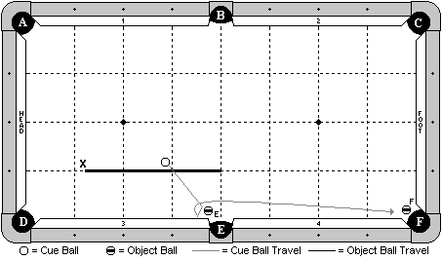

Cue Ball
In hand behind the ‘X’ line.
Object Balls
‘E’ ball is near pocket ‘E’ and adjustable. ‘F’ ball is hanging near pocket ‘F’.
Objective
Shoot the cue ball and make ‘E’ ball. The cue ball will then contact cushion 3, and force follow forward to make ‘F’ ball.
Special Notes
The cue ball must contact ball ‘E’ prior to contacting cushion 3. The cue ball must contact cushion 3. It may not make ‘E’ ball and simply carom down the rail to make ‘F’ ball.

Discipline 4 – Shot 1b – 6 points - Up The Rail Shot

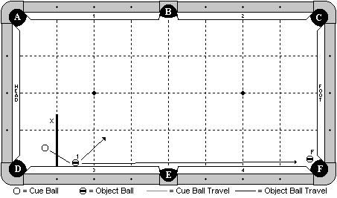

Cue Ball
In hand behind ‘X’ line.
Object Balls
The 1 ball is frozen to the cushion at 1 ½ diamonds. ‘F’ ball is hanging near pocket ‘F’.
Objective
Shoot the cue ball into the 1 ball. The cue ball will force follow down the table and make ‘F’ ball.
Special Notes
This is not a carom shot. Players may not simply glance off the side of the 1 ball and roll down to make ‘F’ ball. Players must hit the 1 ball full (approximately) and force follow down the table. Decision of the table judge is final.

Discipline 4 – Shot 1c – 6 points - The Mystery 9-Ball Shot

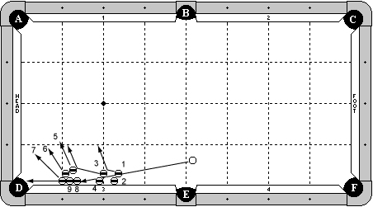

Cue Ball
In hand, behind short center line of table.
Object Balls
7 ball is frozen to cushion 3 at first diamond from pocket ‘D’.
9 ball is frozen to 7 ball and cushion 3, as diagrammed.
8 ball is frozen to 9 ball and cushion 3, as diagrammed.
6 ball is frozen to 7 ball.
5 ball is frozen to 6 ball.
4 ball is frozen to cushion 3, at least two balls spacing from 8 ball.
3 ball is frozen to 4 ball.
2 ball is frozen to cushion 3 at least one ball spacing from 4 ball.
1 ball is frozen to 2 ball.
Objective
Shoot cue ball in to 1 ball. The 1 ball will bank the 2 ball out of the way and carom in to the 3 ball. The 3 ball will bank the 4 ball out of the way and carom in to the 5 ball. The 5, 6, and 7 balls will all clear out of the way. The cue ball will follow forward, hitting the 8 ball and causing the 9 ball to go in pocket ‘D’.
Special Notes
The 9 ball may not be contacted by any balls on its way to the pocket.

***It is strongly encouraged players use the 1-9 balls with the 1 ball and 9 ball in the positions as diagrammed so spectators can have a better understanding of the shot.

Discipline 4 – Shot 2a – 7 points - The Machine Gun Follow Shot

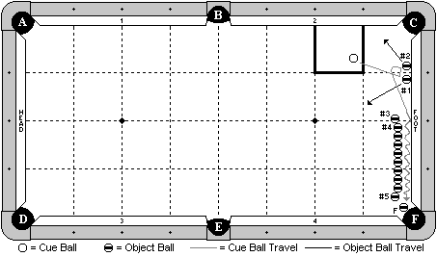

Cue Ball
In hand within the indicated zone.
Object Balls
Balls 1 & 2 are frozen to the foot cushion and centered around the 1st diamond. ‘F’ ball is hanging near pocket ‘F’. A row of 10 balls is approximately 1 ball’s width off the cushion, but this spacing may be adjusted by the player. The row must be straight (parallel to the foot cushion), with the option of adjusting balls 3, 4, and/or 5. If this option is used, those balls must still remain frozen to the others in the line.
Objective
Shoot the cue ball to ball # 1, then carom into ball # 2, and then travel between the row of balls and the cushion. The cue ball will hit at least 4 object balls, and then go on to make ‘F’ ball.
Special Notes
The cue ball must hit ball 1 first, then ball 2. The cue ball must make ‘F’ ball. It may not be made by an object ball. If the cue ball comes to a stop and is later helped by another ball coming in contact with the row of balls or the cue ball, the shot is no good. The cue ball must make ‘F’ ball on its own. Decision of the table judge is final.

Discipline 4 – Shot 2b – 7 points - The Recoil Shot

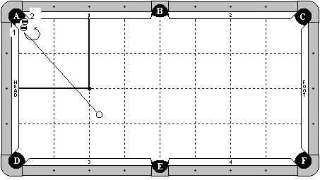

Cue Ball
In hand outside the indicated zone.
Object Balls
The 1 ball is a special stacking ball. The 2 ball is balanced on top of it.
Objective
Shoot the cue ball into the 1 ball, making it in pocket ‘A’. The 2 ball will fall in place. The cue ball must hit either the long rail or the head rail, and then it will follow forward and make the 2 ball.
Special Notes
The referee will stand close to make sure the cue ball hits a cushion before making the 2 ball. Decision of the referee is final.

Discipline 4 – Shot 2c – 7 points - The Kiss Back Shot

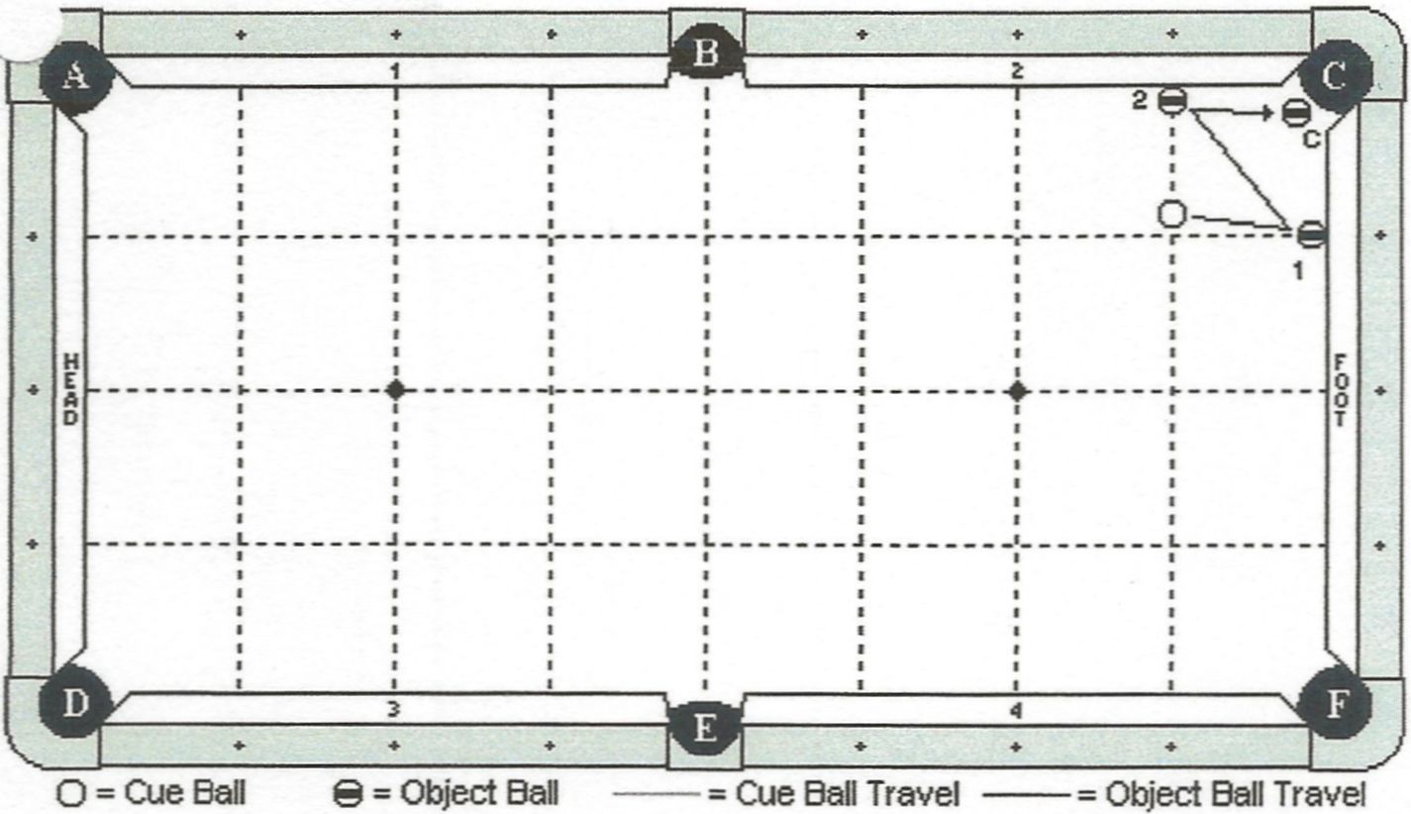

Cue Ball
In hand along 1 diamond segment on long rail.
Object Balls
Object ball ‘1’ is frozen to foot cushion between ½ diamond and 1 diamond.
Object ball ‘2’ is in hand along 1st diamond line. ‘C’ ball is hanging.
Objective
Shoot cue ball into ‘1’ ball. The cue ball will then rebound to ‘2’ ball, and then rebound to ‘C’ ball. ‘C’ ball must be made in ‘C’ pocket. The cue ball may contact cushion ‘2’ before or after contact with ball ‘2’.
Special Notes
Cue ball may not contact foot cushion until after it contact object ball ‘2’. ‘C’ ball may not be touched by any ball other than the cue ball.

Discipline 4 – Shot 3a – 8 points - Inside Spinner

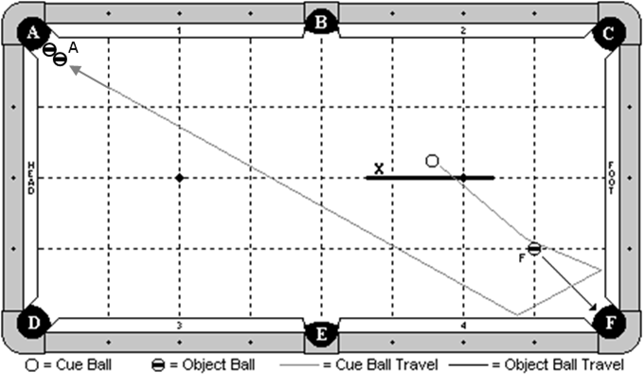

Cue Ball
In hand behind the indicated line.
Object Balls
‘F’ ball on the 1-1 diamond intersection line. ‘A’ ball combo is hanging near pocket ‘A’.
Objective
Shoot the cue ball and make ‘F’ ball in pocket ‘F’. The cue ball will follow forward 2 cushions as diagrammed, and make ‘A’ ball combo in pocket ‘A’.
Special Notes
None

Discipline 4 – Shot 3b – 8 points - The Zip Shot

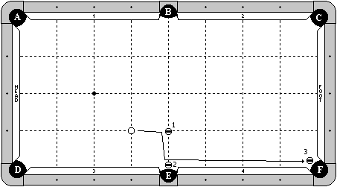

Cue Ball
In hand along the 3rd diamond line.
Object Balls
1 ball is on the diamond intersection line as diagrammed. 2 & 3 balls are hanging near their respective pockets, no more than one ball width from the cut of the pocket.
Objective
Shoot the cue ball into the 1 ball. The cue ball will carom over and make the 2 ball, and then follow down to make the 3 ball.
Special Notes
The 1 ball does not have to be made. The 1 ball may not interfere with the shot until after the 3 ball is made.

Discipline 4 – Shot 3c – 8 points - The Circular Follow

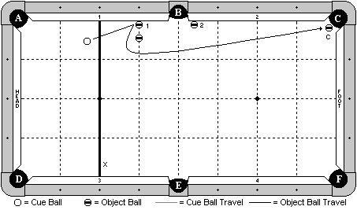

Cue Ball
In hand behind line 'X'.
Object Balls
Object ball 1 frozen to cushion 1 and in line with diamond 3. Object ball 2 frozen to cushion 2, may be placed anywhere within 1 diamond from pocket 'B'. 'C' ball hanging. A blocking ball is placed in line with diamond 3, and 1 ball's width from object ball 1.
Objective
Shoot cue ball to object ball 1. The cue ball will curve around the blocking ball, making 'C' ball.
Special Notes
Object ball 2 is an obstacle only. Object balls 1 and 2 do not have to be made. The cue ball may not contact the blocking ball or object ball 2 until after 'C' ball has been made. Cue ball may only contact cushions '1', '2', or the foot cushion, until after 'C' ball is made.

Discipline 4 – Shot 4a – 9 points - The Window Shot

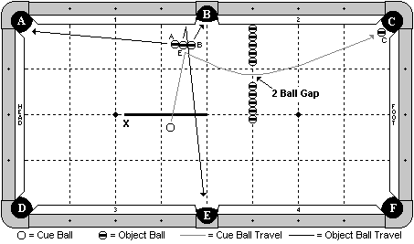

Cue Ball
In hand behind the indicated line.
Object Balls
‘B’ and ‘E’ balls are frozen and exactly 2 ball’s width off the cushion, and adjustable left or right. ‘A’ ball is adjustable and frozen to ‘E’ ball. ‘C’ ball is hanging near pocket ‘C’. A line of 10 object balls are along the 3rd diamond line. A gap of 2 ball’s width is between the first 5 balls and the last 5 balls.
Objective
Shoot the cue ball and make the three balls as pocket letter designates. The cue ball will travel the indicated path through the gap, and follow forward to make ‘C’ ball.
Special Notes
The blocking balls may not be touched by any means until after ‘C’ ball is made.

Discipline 4 – Shot 4b – 9 points - Out Of My Way

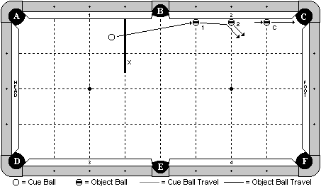

Cue Ball
In hand behind the indicated line.
Object Balls
1 and 2 balls are on their indicated diamond lines and frozen to the cushion. ‘C’ ball is on the 1st diamond and adjustable along that line.
Objective
Shoot the cue ball into the 1 ball. The 1 ball will hit the 2 ball and both will clear. The cue ball will follow forward and make ‘C’ ball.
Special Notes
‘C’ ball may not be contacted by any ball other than the cue ball.

Discipline 4 – Shot 4c – 9 points - The Zig Zag Shot

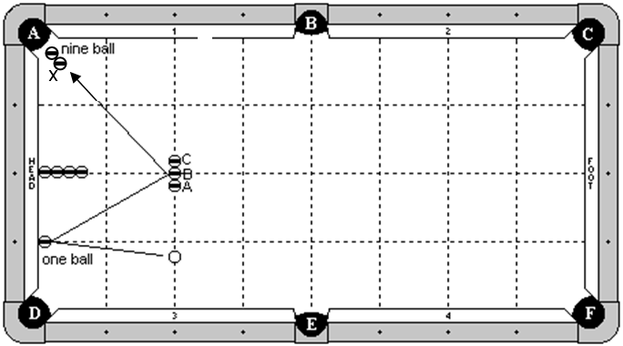

Cue Ball
In hand along the 2nd diamond line.
Object Balls
1 ball frozen to the head cushion at the 1st diamond. ‘A’, ‘B’, and ‘C’ balls are frozen in line along the head string with ‘B’ ball on the head spot. 4 blocker balls are along the 2nd diamond line with the first ball frozen to the cushion. The 9 ball is hanging near pocket ‘A’. ‘X’ ball is frozen to the 9 ball as a helper.

Objective
Shoot the cue ball into the 1 ball. The cue ball will double kiss back into the line of three balls (A,B,C), and then follow forward to make the 9 ball.
Special Notes
The cue ball may not contact any cushions except possibly the head cushion or cushion 1 near pocket ‘A’. The cue ball may contact any combination of ‘A’,’B’,’C’ balls. The 4 blocker balls may not be contacted by the cue ball until after the 9 ball is made.

Discipline 4 – Shot 5a – 10 points - Gerni’s Three Plus One

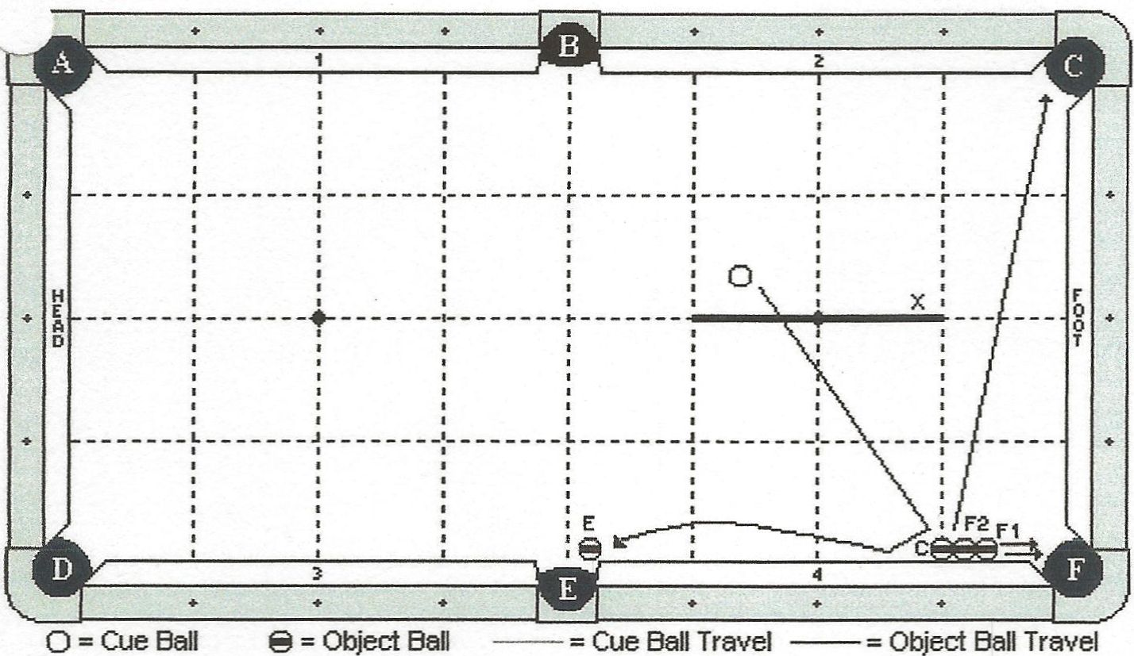

Cue Ball
In hand behind line ‘X’.
Object Balls
‘C’ ball and both ‘F’ balls are in line and frozen is to cushion 4. ‘C’ ball is in line with the first diamond. ‘E’ ball is hanging.
Objective
Shoot the cue ball into ‘C’ ball. It will then travel along the cushion 4, making ‘E’ ball. All four balls will go as pocket letter designates.
Special Notes
Cue ball may not contact any cushion except cushion 4 until after ‘E’ ball is made.

Discipline 4 – Shot 5b – 10 points - The Follow Bender

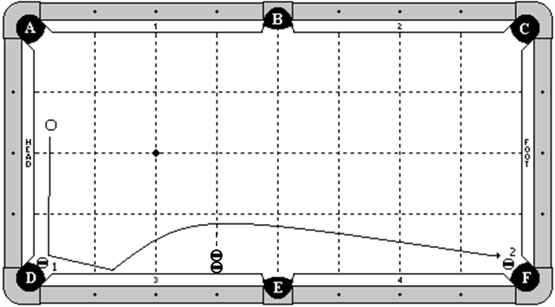

Cue Ball
In hand behind the long center line of the table.
Object Balls
1 ball is hanging near pocket ‘D’ and adjustable. 2 ball is hanging near pocket ‘F’. Two blocker balls are frozen in line along the 3rd diamond.
Objective
Shoot the cue ball into the 1 ball, making it in pocket ‘D’. The cue ball will hit cushion 3, bounce out and around the two blocker balls, and make the 2 ball.
Special Notes
The blocker balls may not be hit by any means until after the 2 ball is made.

Discipline 4 – Shot 5c – 10 points - Follow The Kiss

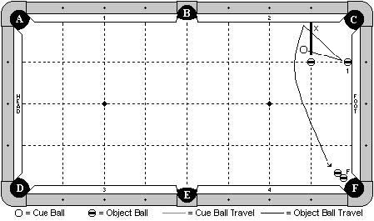

Cue Ball
In hand behind line ‘X’, as diagrammed.
Object Balls
Object ball ‘1’ is frozen to the foot cushion at 1 diamond segment.
Blocking ball is placed at the 1x1 diamond intersection.
Two ball combination is hanging by pocket ‘F’.
Objective
Shoot cue ball into 1 ball. Cue ball will double kiss back off cushion 2 and curve around blocking ball, hit the two ball combination, and pocket ‘F’ ball.
Special Notes
Cue ball may not contact foot cushion before contacting cushion 2.
The blocking ball may not be contact by any means until after ‘F’ ball is made.
Extra contacts between the 1 ball and cue ball are not allowed.

DISCIPLINE

5

BANK / KICK SHOTS

Discipline 5 – Shot 1a – 6 points - The Triple Reverse Bank

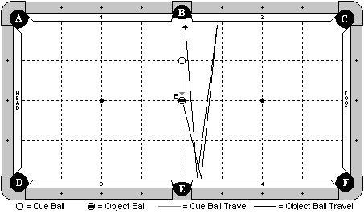

Cue Ball
On the diamond intersection line as diagrammed.
Object Balls
‘B’ ball on the exact center spot of the table.
Objective
Shoot the cue ball into ‘B’ ball. ‘B’ ball will bank three cushions as diagrammed (cushion 4, cushion 2, cushion 4), and go into pocket ‘B’.
Special Notes
None

Discipline 5 – Shot 1b – 6 points - The Cozy Kick Shot

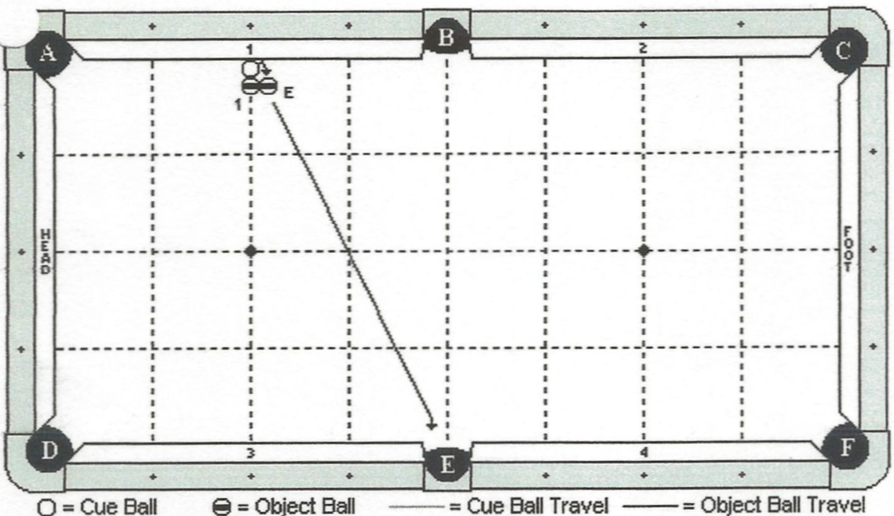

Cue Ball
Frozen to cushion 1, on head string.
Object Balls
Object ball ‘1’ is along head string, frozen to cue ball. ‘E’ ball is frozen to object ball ‘1’. 1 ball’s width from cushion 1.
Objective
Shoot the cue ball into cushion 1, compressing the rail. The cue ball will contact ‘E’ ball, making it in pocket ‘E’.
Special Notes
Object ball ‘1’ may not be touched by any means until after ‘E’ ball has been made.

Discipline 5 – Shot 1c – 6 points - Pelinga’s Backward Bank

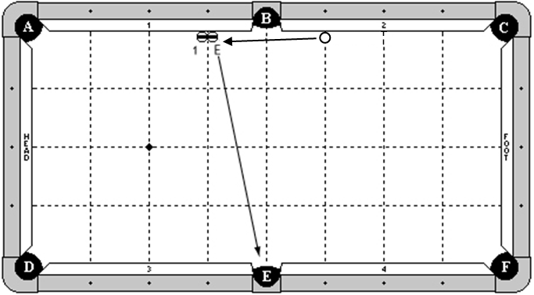

Cue Ball
Frozen to cushion 2 on 3rd diamond line.
Object Balls
1 ball and ‘E’ ball are frozen to each other and to cushion 1. They are split on the 3rd diamond.
Objective
Shoot cue ball in to ‘E’ ball causing ‘E’ ball to bank in to pocket ‘E’.
Special Notes
‘E’ ball may not be contacted again after the initial hit.

Discipline 5 – Shot 2a – 7 points - The Double Shot

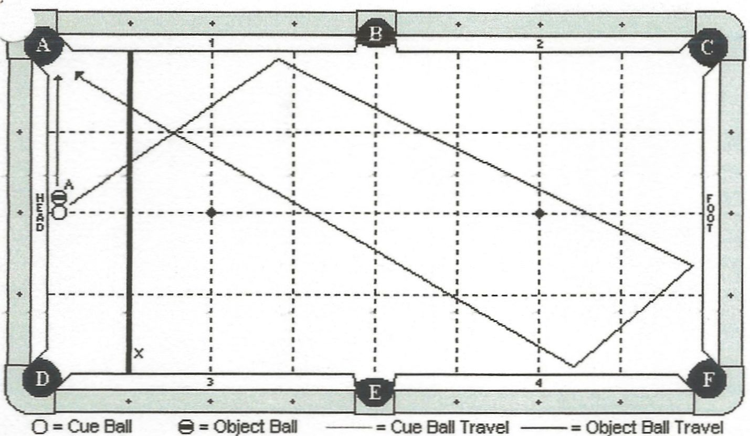

Cue Ball
In hand, on center line of table behind line ‘X’.
Object Balls
‘A’ ball is in hand, frozen to the cue ball.
Objective
Shoot the cue ball, making ‘A’ ball in pocket ‘A’. The cue ball will travel three cushions and scratch in pocket ‘A’.
Special Notes
None.

Discipline 5 – Shot 2b – 7 points - “The Hustler” Bank Shot

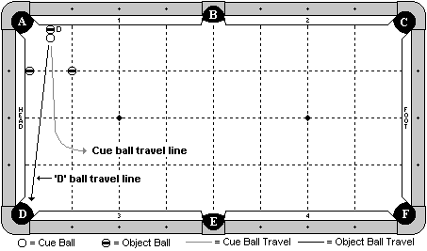

Cue Ball
Along the ½ diamond line, frozen to ‘D’ ball.
Object Balls
‘D’ ball along the ½ diamond line, frozen to the cushion. A blocker ball is on the 1st diamond line, frozen to the head cushion. Another blocker ball is on the 1-1 diamond intersection line.
Objective
Shoot the cue ball and cause ‘D’ ball to bank back into pocket ‘D’. The cue ball must come out between the two blocker balls.
Special Notes
The blocker balls may not be contacted by any means until after ‘D’ ball is made. The cue ball and ‘D’ ball may contact each other multiple times.

Discipline 5 – Shot 2c – 7 points - There & Back Again

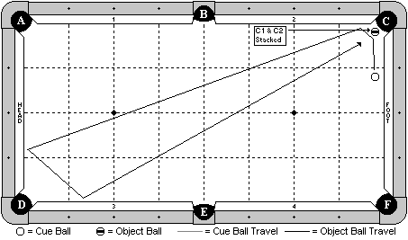

Cue Ball
In hand, behind 1st diamond line from pocket ‘C’.
Object Balls
A stacker ball is hanging near pocket ‘C’. An object ball is balanced on top of it.
Objective
Shoot the cue ball into the stacker ball, making it in pocket ‘C’ and causing the object ball to fall in place. The cue ball will travel three cushions as diagrammed, and make the object ball in pocket ‘C’.
Special Notes
None

Discipline 5 – Shot 3a – 8 points - Poolhall Junkie Bank Shot

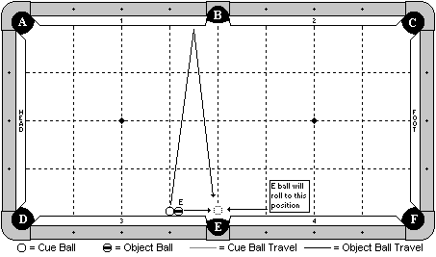

Cue Ball
Frozen to the cushion at the 3rd diamond.
Object Balls
‘E’ ball frozen to the cushion and to the cue ball.
Objective
Shoot the cue ball to bank one rail as diagrammed. ‘E’ ball will roll in front of pocket ‘E’. The cue ball will bank back into ‘E’ ball and make it in pocket ‘E’.
Special Notes
None

Discipline 5 – Shot 3b – 8 points - The Escape Kick Shot

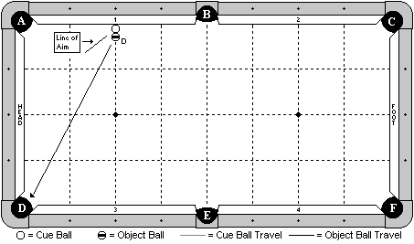

Cue Ball
Frozen to the cushion at the 2nd diamond.
Object Balls
‘D’ ball along the 2nd diamond, frozen to the cue ball.
Objective
Shoot the cue ball into the cushion along the line of aim indicated by the diagram. The cue ball will back cue ‘D’ ball into ‘D’ pocket.
Special Notes
None

Discipline 5 – Shot 3c – 8 points - The Quick Timer Shot

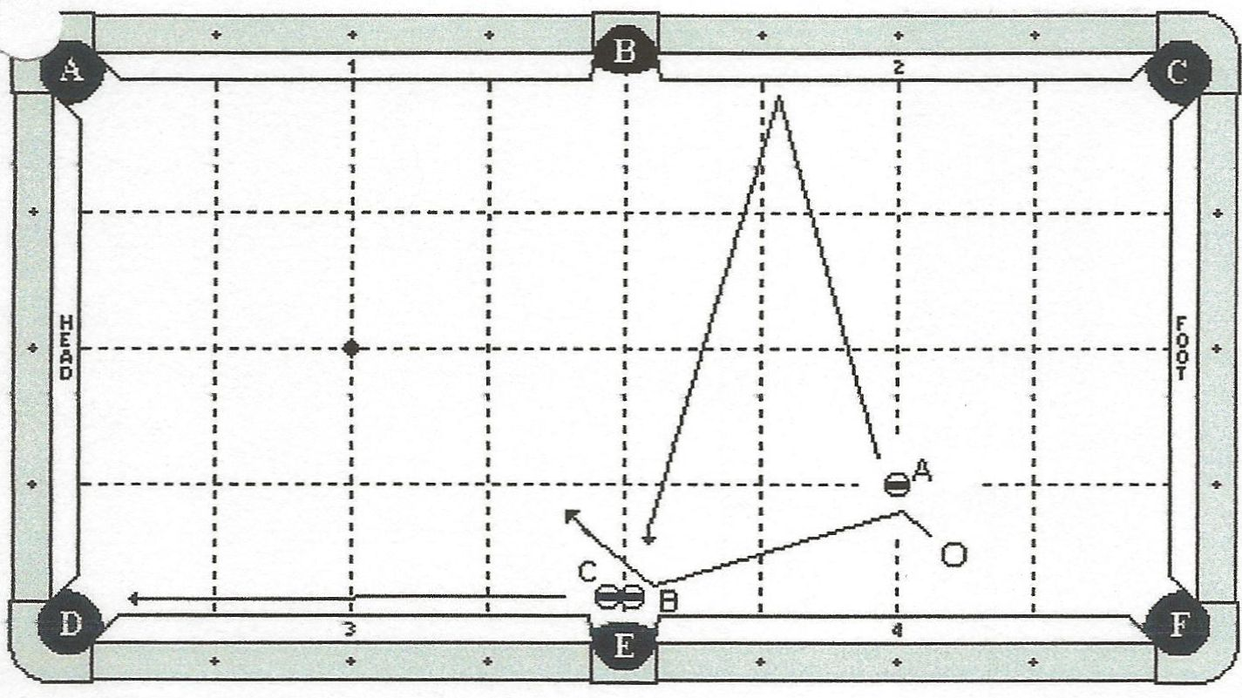

Cue Ball
In hand.
Object Balls
‘A’ ball on the intersection of the foot string and the 1st diamond line as indicated by diagram. ‘B’ and ‘C’ balls are frozen and in hand near pocket E.
Objective
Shoot the cue ball into the ‘A’ ball, causing it to bank into pocket E. The cue ball will travel down and hit ‘B’ ball, causing ‘B’ ball to go into the side pocket and ‘C’ ball to go into the corner pocket.
Special Notes
‘A’ ball will go into pocket E last. Extra contact between any of the balls is allowed. Scratch is allowed.

Discipline 5 – Shot 4a – 9 points - Pelinga’s Kicker

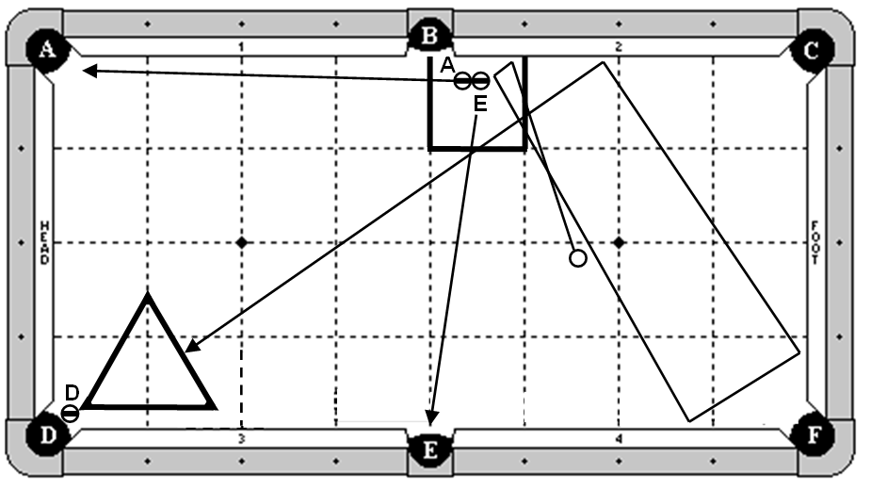

Cue Ball
In hand behind long centerline.
Object Balls
‘A’ and ‘E’ balls are in hand within box zone. ‘D’ ball is hanging with rack in hand.
Objective
Shoot the cue cushion, kicking into ‘E’ ball. ‘E’ and ‘A’ object balls will go in as diagrammed. Cue ball will travel diagrammed path, hit the rack and make ‘D’ ball in the corner pocket.
Special Notes
None.

Discipline 5 – Shot 4b – 9 points - The Five Rail Kick

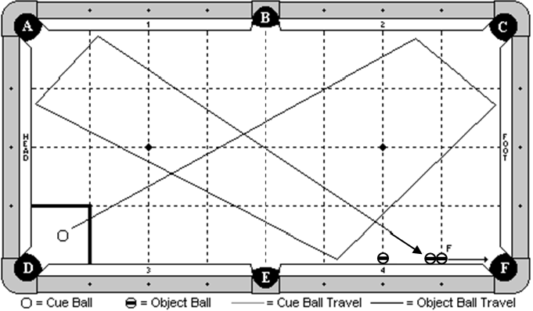

Cue Ball
In hand within the indicated zone.
Object Balls
‘F’ ball is frozen to cushion on 1st diamond line with combo ball frozen to F ball and rail. A blocker ball is frozen to cushion on 2nd diamond line as diagrammed.
Objective
Shoot the cue ball 5 cushions as diagrammed, and make ‘F’ ball in pocket ‘F’.
Special Notes
Blocker ball may not be contacted until F ball is made.

Discipline 5 – Shot 4c – 9 points - The Speedy Skater

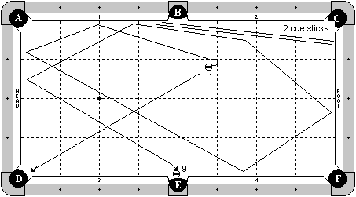

Cue Ball
In hand behind the B-E center line (on the foot cushion side of the table).
Object Balls
1 ball in hand, frozen to the cue ball, and also must be to the right of the B-E center line. 9 ball is hanging near pocket ‘E’. Two cue sticks are placed on the table as diagrammed, with their butt ends near the foot cushion. Players have the option of using both cue sticks as diagrammed, or just one cue stick.
Objective
Shoot the cue ball to make the 1 ball in pocket ‘D’. The cue ball will travel 4 cushions as diagrammed, hit the cue stick, then travel 2 more cushions and make the 9 ball.
Special Notes
Players selecting this shot will be required to supply the 2 cue sticks.

Discipline 5 – Shot 5a – 10 points - The ‘Z’ Bank Shot

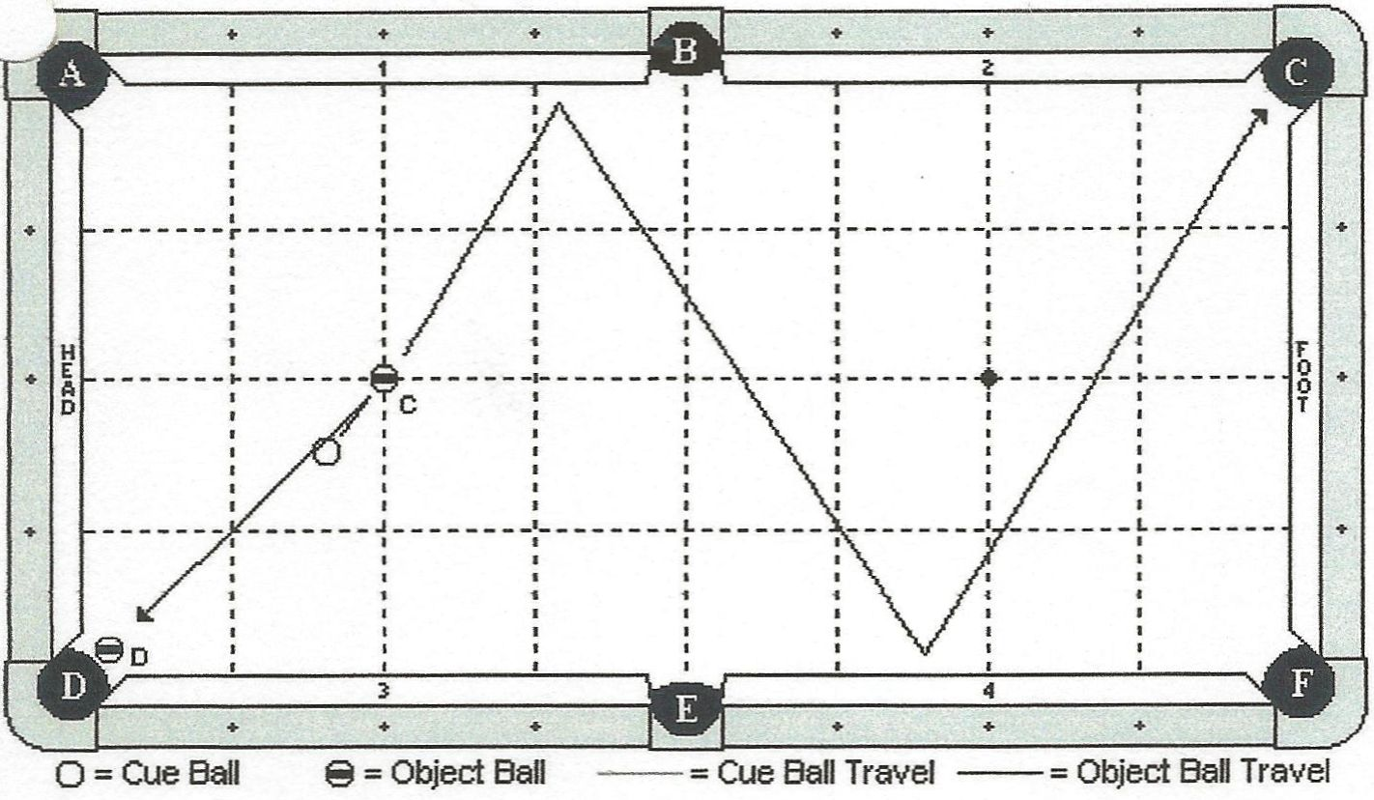

Cue Ball
In hand.
Object Balls
‘C’ ball is on the head spot. ‘D’ ball is hanging near pocket ‘D’.
Objective
Shoot cue ball into ‘C’ ball, banking it 2 rails as diagram indicates, into pocked ‘C’. The cue ball will draw back making ‘D’ ball.
Special Notes
Scratch is allowed.

Discipline 5 – Shot 5b – 10 points - The Efren Reyes Bank Shot
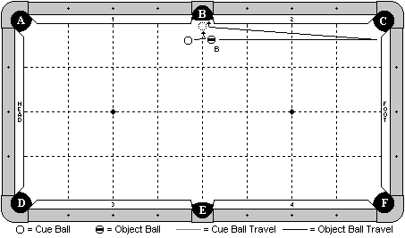

Cue Ball
In hand.
Object Balls
‘B’ ball in hand.
Objective
Shoot the cue ball into ‘B’ ball, causing it to bank off the foot cushion, optionally hit cushion 2, and then carom off the cue ball and go into pocket ‘B’.
Special Notes
None

Discipline 5 – Shot 5c – 10 points - Rat Race

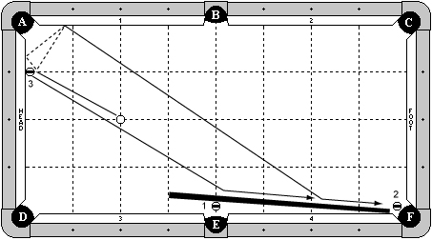

Cue Ball
On head spot.
Object Balls
3 ball frozen to head cushion, one diamond from pocket ‘A’.
1 ball hanging in pocket ‘E’ with edge even with the pocket cut or deeper.
2 ball hanging near pocket ‘F’.
A short cue is placed as diagrammed. The end of the cue may not be past one diamond to the left of pocket ‘E’.
Objective
Shoot cue ball into 3 ball. 3 ball will bank into pocket ‘F’. Cue ball will optionally hit the head cushion, but will hit cushion 1, then the cue stick, making 1 ball in pocket ‘E’, and roll down the cue stick making 2 ball in pocket ‘F’. Then the 3 ball will go in to pocket ‘F’.
Special Notes
All balls must be made in numerical order.
Extra contact between cue ball and 3 ball is okay.

DISCIPLINE

6

STROKE SHOTS

Discipline 6 – Shot 1a – 6 points - The Resistance Draw

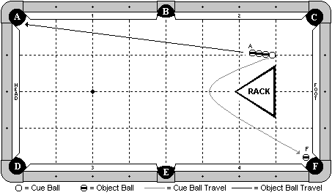

Cue Ball
In hand, but the back edge must be aligned with the 1st diamond.
Object Balls
Three balls are in line and frozen to each other and to the cue ball. ‘F’ ball is hanging near pocket ‘F’. The rack is centered along the long center line of the table, and the back edge is aligned with the 1st diamond.
Objective
Shoot the cue ball into the line of 3 balls. The first ball (‘A’) will go into pocket ‘A’. The cue ball will curve around the rack and make ‘F’ ball.
Special Notes
The other two balls in line do not need to be made. The cue ball may not contact the rack until after ‘F’ ball is made. Once the cue ball is struck and it separates from the line of balls, the cue ball may not be contacted by any other ball until ‘F’ ball is made. If the rack has a lip, it will be placed lip down.

Discipline 6 – Shot 1b – 6 points - The Jump Draw Shot

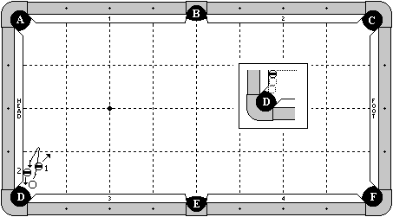

Cue Ball
In hand, but the right edge may not be past the pocket point on cushion 3.
Object Balls
2 ball is frozen to the head cushion, and is the third ball out from the pocket cut. See the close-up view for more information. The 1 ball is in hand, but may be no more than 1 chalk’s width from the 2 ball. Also, the back edge of the 1 ball may not be past the forward edge of the 2 ball (indicated in the close-up view by a dotted line).
Objective
Shoot the cue ball into the 1 ball. The cue ball will jump over and draw back, making the 2 ball in pocket ‘D’.
Special Notes
The cue ball may make multiple hits on the 2 ball and head cushion. The cue ball may not contact any other cushion until hitting the 2 ball on the way back. The 1 ball does not need to be made.

Discipline 6 – Shot 1c – 6 points - The Double Kiss Draw Shot

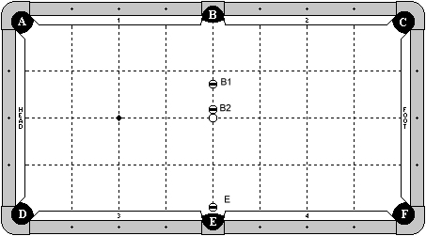

Cue Ball
On center spot.
Object Balls
All object balls on center line of table.
‘B2’ ball frozen to cue ball.
‘B1’ ball exactly two ball widths from ‘B2’ ball.
‘E’ ball hanging in pocket ‘E’, even with the rail line extension or deeper.
Objective
Shoot cue ball in to ‘B2’ ball. ‘B2’ ball will hit ‘B1’ ball in to pocket ‘B’. Cue ball will contact ‘B2’ ball a second time, hitting it in to pocket ‘B’. Cue ball will then draw back making ‘E’ ball.
Special Notes
‘E’ ball must be on center line. It is not adjustable left or right.

Discipline 6 – Shot 2a – 7 points - The Triple Lag Shot

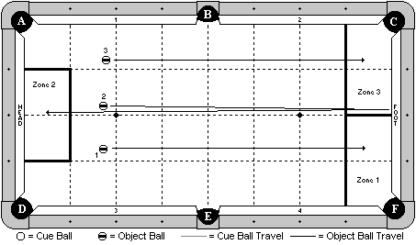

Cue Ball
None
Object Balls
All three balls are in hand behind the head string.
Objective
Shoot the 1 ball, then the 2 ball, and finally the 3 ball. The 1 ball must go straight into and stop within zone 1, the 2 ball must bank one cushion as diagrammed and stop within zone 2, and the 3 ball must go straight into and stop within zone 3.
Special Notes
The 1 ball and the 3 ball may hit the foot cushion, but no other. The 2 ball will hit the foot cushion, and may hit the head cushion, but no other. All balls must be hit before the 1 ball comes to a stop OR hits the foot cushion. Table judge decision is final.

Discipline 6 – Shot 2b – 7 points - Don’t Knock The Ball Off

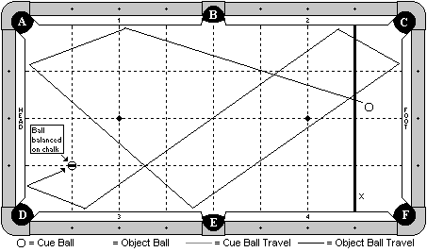

Cue Ball
In hand behind the indicated line.
Object Balls
An object ball is balanced on a piece of new chalk (well up). The chalk is centered on the 1-1 diamond intersection line, and square with the table.
Objective
Shoot the cue ball 7 cushions as diagrammed. The cue ball must make contact with the object ball and the object ball may not fall off the chalk.
Special Notes
None

Discipline 6 – Shot 2c – 7 points - Ducks in a Row

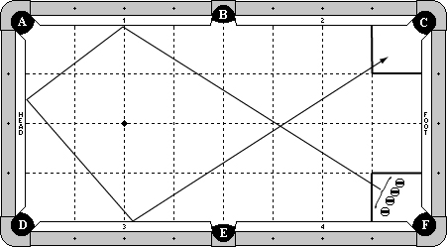

Cue Ball
None.
Object Balls
Four object balls are in hand in 1x1 diamond zone by pocket ‘F’.
Objective
Shoot each object ball three rails into 1x1 diamond zone by pocket ‘C’.
Special Notes
Each object ball may hit on either side of pocket ‘B’ for the first cushion contact.
Fourth ball hit must cross in front of the first ball hit coming off the third rail.
Extra cushion contacts by pocket ‘C’ are allowed.
If a ball is pocketed, the shot is no good.
Extra ball contacts on the way to the finish zone are allowed.
Extra ball contacts inside the finish zone are also allowed.
All four object balls must come to rest in the 1x1 diamond zone.

Discipline 6 – Shot 3a – 8 points - The Close Draw Drag

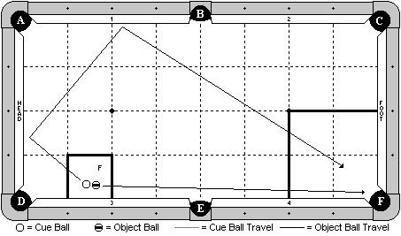

Cue Ball
In hand within the indicated zone.
Object Balls
‘F’ ball in hand within the indicated zone. The gap between the cue ball and ‘F’ ball is exactly 2mm.
Objective
Shoot the cue ball and make ‘F’ ball in pocket ‘F’. The cue ball will draw 2 cushions as diagrammed, and come to rest within the indicated zone.
Special Notes
If the cue ball scratches in pocket ‘F’, the shot is good.

Discipline 6 – Shot 3b – 8 points - Giumelli’s Rendezvous

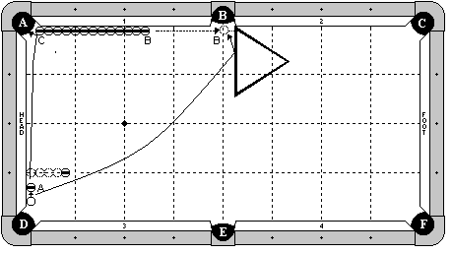

Cue Ball
Frozen to the head cushion, and the back edge is aligned with the pocket point.
Object Balls
‘A’ ball frozen to the head cushion and adjustable. 13 balls are in line, all frozen to cushion 1. The first ball (‘C’) may be inside the pocket jaws. A blocker ball is on the 1st diamond, exactly 4 ball’s width from the cushion. A rack is wedged into the side pocket, and the left edge is perpendicular to the cushion.
Objective
Shoot the cue ball into the ‘A’ ball, making it in pocket ‘A’. The ball will carom off ‘C’ ball, causing ‘B’ ball to travel up the rail, possibly hitting the rack and sitting in front of the pocket. The cue ball will curve around the blocker ball and make ‘B’ ball in pocket ‘B’, optionally hitting the rack on its way.
Special Notes
The blocker ball may not be contacted by any means until after ‘B’ ball has been made. The rack must be perpendicular. When ‘B’ ball hits the rack, it may not go in on its own. It must sit there and wait for the cue ball to knock it in.

Discipline 6 – Shot 3c – 8 points - The Koufax Curveball

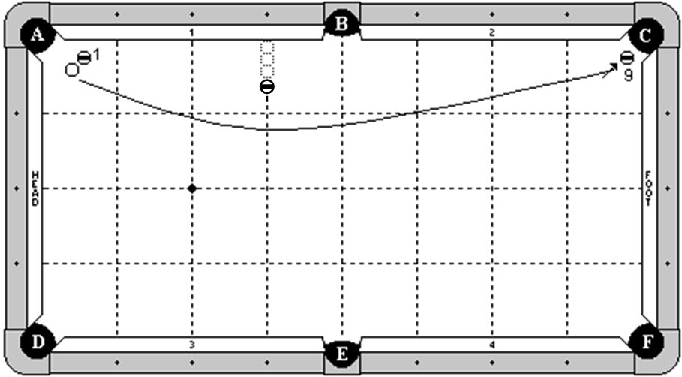

Cue Ball
In hand, but no more than ½ ball’s width from the ball #1.
Object Balls
Ball #1 is 1 ball’s width off cushion 1, and may be adjusted anywhere along the cushion, up to the 1st diamond line. Ball # 9 is hanging near pocket ‘C’. A blocking ball is placed on the 3rd diamond line, exactly 3 ball’s width off the cushion.
Objective
Shoot the cue ball into the 1 ball. The cue ball will curve around the blocking ball and make the 9 ball.
Special Notes
The blocking ball may not be contacted by any means until after the 9 ball is made.
Extra contact between the cue ball and 1 ball is allowed, provided that the cue ball makes the 9 ball.

Discipline 6 – Shot 4a – 9 points - The X-treme Hustler Bank Shot

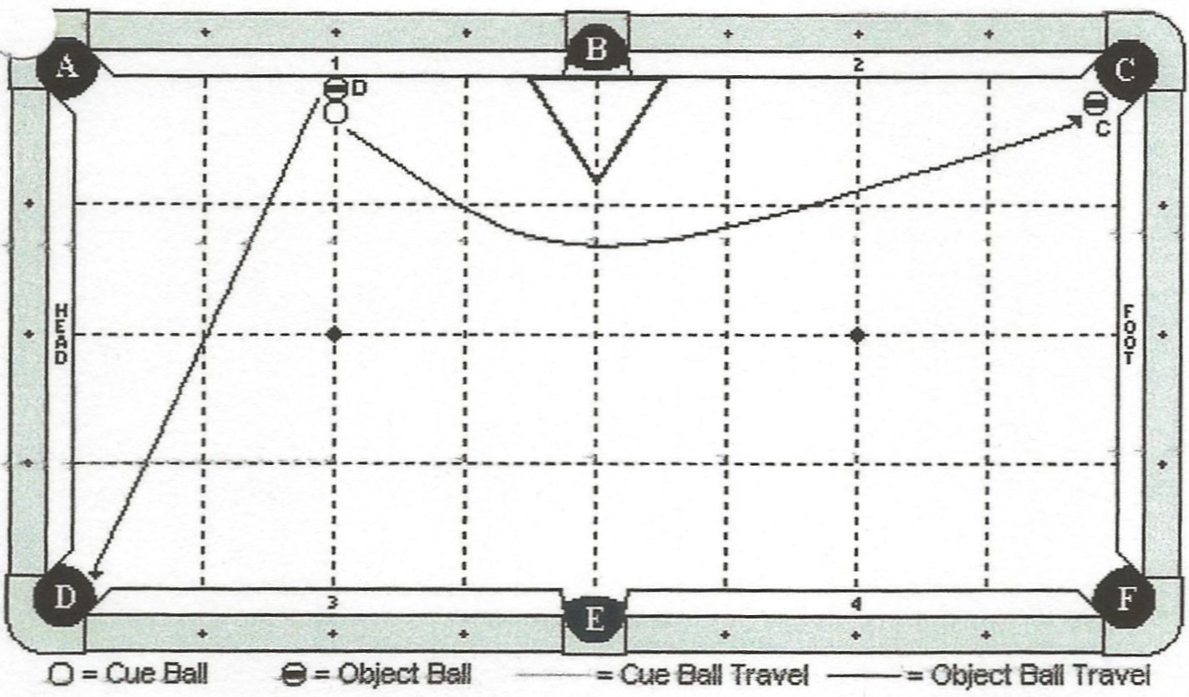

Cue Ball
In hand, frozen to ‘D’ ball.
Object Balls
‘D’ ball is in hand, frozen to cushion 1 and cue ball, ‘C’ ball is hanging.
Objective
Shoot cue ball into ‘D’ ball, banking it into ‘D’ pocket. Cue ball will force follow around rack, making ‘C’ ball.
Special Notes
The rack is in hand but must be frozen to cushion 1 and/or cushion 2. The rack may not be contacted by any means until after both object balls have been made. Cue ball may contact cushion 2 or the foot cushion, but no other until after ‘C’ ball is made.

Discipline 6 – Shot 4b – 9 points - The Showoff Spin Shot

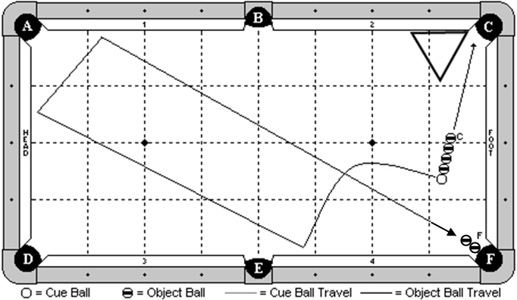

Cue Ball
In hand, but no more than 2 diamonds away from the foot cushion.
Object Balls
4 balls are frozen in line, and to the cue ball. ‘F’ ball combo is hanging near pocket ‘F’.
A rack is in hand, frozen to cushion 2.
Objective
Shoot the cue ball into the line of 4 balls. All four object balls will go into pocket C. The cue ball will draw back and around 3 cushions as diagrammed, and make ‘F’ ball.
Special Notes
The cue ball may hit cushion 3 or 4 as the first cushion.

Discipline 6 – Shot 4c – 9 points - Splitting The Chopsticks

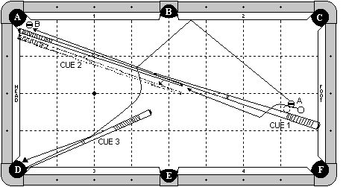

Cue Ball
In hand, but may not be more than 1 chalk’s width from ‘A’ ball.
Object Balls
‘A’ ball is approximately 1 ball’s width from the cue stick, but it is adjustable. ‘B’ ball is hanging near pocket ‘A’. Three cue sticks are on the table. Cue stick # 1 has the butt end against the foot cushion at the 1st diamond. Cue stick 2 has the butt end against the head cushion. Both cue stick 1 and 2 meet at the tip end and the sticks are both lined up so there is no gap between the sticks where they meet. Cue stick # 3 has the tip end wedged into pocket ‘D’ and it adjustable.
Objective
Shoot the cue ball into ‘A’ ball. ‘A’ ball will bank off cushion 2, hit and jump over the sticks (separating them), hit cue stick # 3 (optional), and go into pocket ‘D’. The cue ball will jump over cue stick # 1, follow between the gap that now exists between the two cue sticks, and make ‘B’ ball in pocket ‘A’.
Special Notes
The cue ball may hit cue stick # 1 when jumping over it. The cue ball must make ‘B’ ball. It may not be hit in by the cue stick. Players selecting this shot are required to supply the 3 cue sticks.

A shot clock with a time limit of 90 seconds will be placed on this challenge for the set up period.

Discipline 6 – Shot 5a – 10 points - The Whip Draw Shot

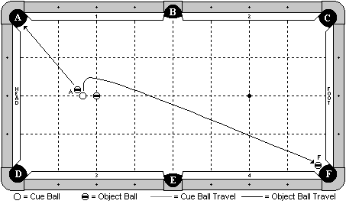

Cue Ball
On the long center line of the table, exactly 1 ball’s width from the ball on the head spot.
Object Balls
A blocker ball is on the head spot. Ball ‘A’ is exactly 2mm from the cue ball. ‘F’ ball is hanging near pocket ‘F’.
Objective
Shoot the cue ball making ‘A’ ball in pocket ‘A’. The cue ball will draw around the blocker ball, and make ‘F’ ball.
Special Notes
The blocker ball may not be touched by any means until after ‘F’ ball is made. Players may not jack up and execute a full masse to make this shot.

Discipline 6 – Shot 5b – 10 points - Opening The Gate

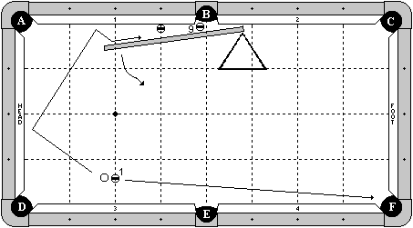

Cue Ball
In hand, but must be exactly 2mm from the 1 ball.
Object Balls
1 ball on the 2nd diamond, and no more than 3 ball’s width from the cushion. 9 ball is hanging near pocket ‘B’. A blocker ball is frozen to cushion 1 and on the 3rd diamond. A short jump cue is in position as diagrammed. It is adjustable, but it may be no more than 1 chalk’s width from the blocker ball. A rack is in position to keep the jump cue from moving too much.
Objective
Shoot the cue ball into the 1 ball, making it in pocket ‘F’. The cue ball will draw back into the head cushion, and then go into the gap between the cue stick and the cushion. The cue ball will swing the jump cue out so the cue ball can go around the blocking ball, and make the 9 ball.
Special Notes
It is okay for the cue ball to hit the blocker ball, provided that the cue ball (not the blocker or the stick) makes the 9 ball. Players selecting this shot will be required to provide the jump cue.

Discipline 6 – Shot 5c – 10 points - The Impossible Stroke

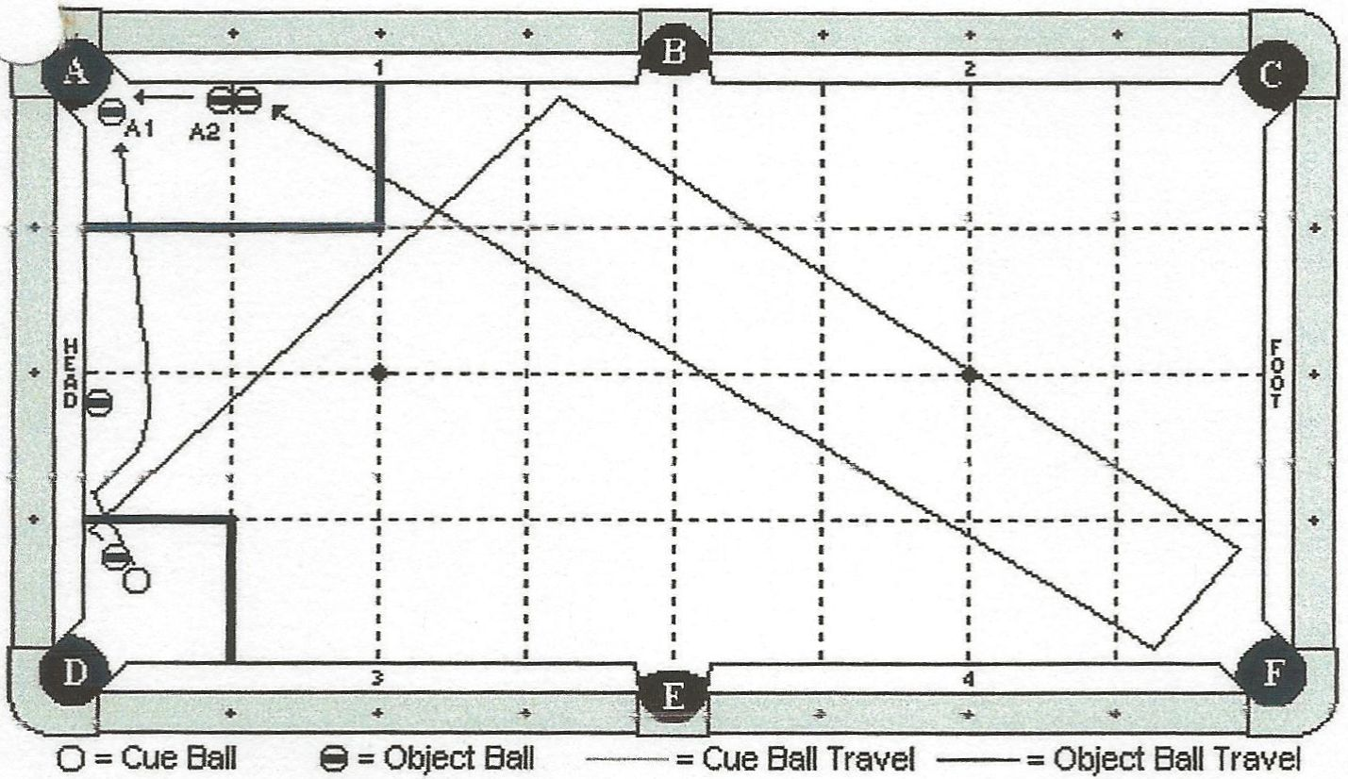

Cue Ball
Anywhere in box zone, no further than 1/8 inch from object.
Object Balls
An object ball is placed close to the cue ball, no further than 1/8 inch away. A blocking ball is placed frozen to the head cushion, but may be positioned anywhere along the head cushion. ‘A1’ ball is hanging. ‘A2’ ball is placed anywhere inside box zone. Another ball is placed frozen to ‘A2’ ball, creating a ‘dead’ combination. This ball must also be within box zone.
Objective
Shoot the cue ball into the closest object ball, causing that object ball to travel 4 rails into the dead combination, making ‘A2’ ball. Before this happens, the cue ball will contact the head cushion before the blocking ball, bounce out and around the blocking ball, making ‘A1’ ball. The cue ball will then either scratch or move out of the way before ‘A2’ ball is made.
Special Notes
The cue ball may not contact the blocking ball until after ‘A1’ ball has been made.
The cue ball may not contact ‘A2’ ball or the ball frozen to it until after ‘A2’ ball has been made.

DISCIPLINE

7

JUMP SHOTS

Discipline 7 – Shot 1a – 6 points - The Jailbreak Shot

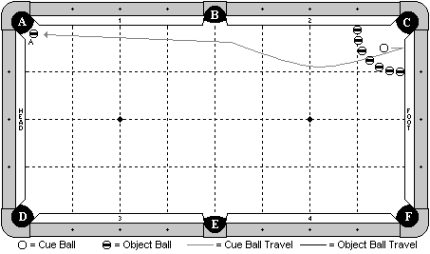

Cue Ball
In hand within the ring of balls.
Object Balls
7 balls form an arc, with the first ball on each end frozen to the cushion at the 1st diamond. The other balls are evenly spaced. ‘A’ ball is hanging near pocket ‘A’.
Objective
Shoot the cue ball into the foot cushion, causing it to jump back and over the ring of balls, and make ‘A’ ball in pocket ‘A’.
Special Notes
The blocker balls may not be contacted by any means until after ‘A’ ball is made.

Discipline 7 – Shot 1b – 6 points - Giumelli’s Rail Jump Shot

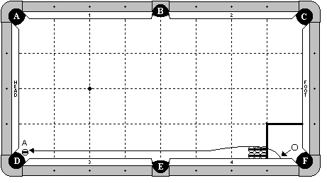

Cue Ball
In hand within the 1x1 diamond zone at least one chalk width from cushion 4.
Object Balls
‘A’ ball is hanging near pocket ‘D’. 6 blocker balls form a 2x3 cluster. All balls are frozen to each other. The three balls along the rail are frozen to the rail. The right most 2 balls have their edge aligned with the 1st diamond.
Objective
Shoot the cue ball into cushion 4, causing it to jump over the blocker balls, and travel down to make the ‘A’ ball in pocket ‘D’.
Special Notes
The blocker balls may not be contacted by any means until after ‘A’ ball is made.

Discipline 7 – Shot 1c – 6 points - The One-hand Jump Shot

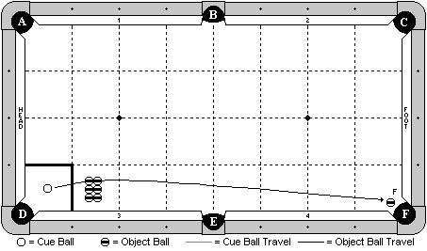

Cue Ball
In hand within the 1x1 diamond zone indicated. It must be positioned so that it will jump over the center of the cluster of blocking balls (approximately).
Object Balls
‘F’ ball is hanging near pocket ‘F’. A 2x3 cluster of balls are all frozen to each other and are in hand within the 1x1 diamond zone immediately to the right of the cue ball’s 1x1 diamond zone.
Objective
Jump the cue ball 1-handed, jacked up, over the blocker balls, and make ‘F’ ball.
Special Notes
The blocker balls may not be contacted by any means until after ‘F’ ball is made.

Discipline 7 – Shot 2a – 7 points - The Kiss Back Hop Shot

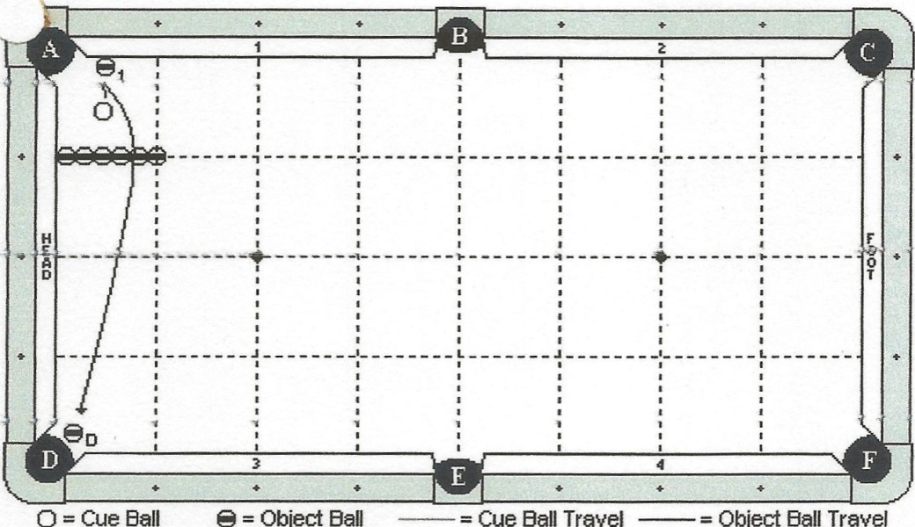

Cue Ball
In hand.
Object Balls
Object ball 1 is frozen to cushion 1, ½ diamond segment from pocket ‘A’. Row of 6 blocking balls starts frozen to head cushion and expends straight up table. Row may be adjusted along head cushion..
Objective
Shoot the cue ball into object ball 1. The cue ball will bounce back and over the row of blocking balls, making ‘D’ ball.
Special Notes
The cue ball may not contact the row of blocking balls until after ‘D’ ball has been made.

Discipline 7 – Shot 2b – 7 points - The Close Jump Shot

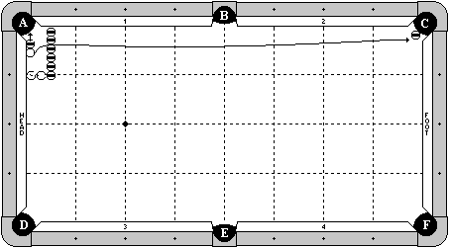

Cue Ball
In hand between head cushion and blocker balls.
Object Balls
‘A’ ball is in hand, but frozen to the cue ball.
‘C’ ball is hanging in pocket ‘C’.
A row of 6 blocker balls is exactly two ball widths from head cushion.
Objectivve
Jump cue ball over the blocker balls. ‘A’ ball will go in to pocket ‘A’. Cue ball will hit ‘C’ ball in to pocket ‘C’.
Special Notes
Blocker balls may not be contacted by any means until after object balls are made.

Discipline 7 – Shot 2c – 7 points - The Double Kiss Jump

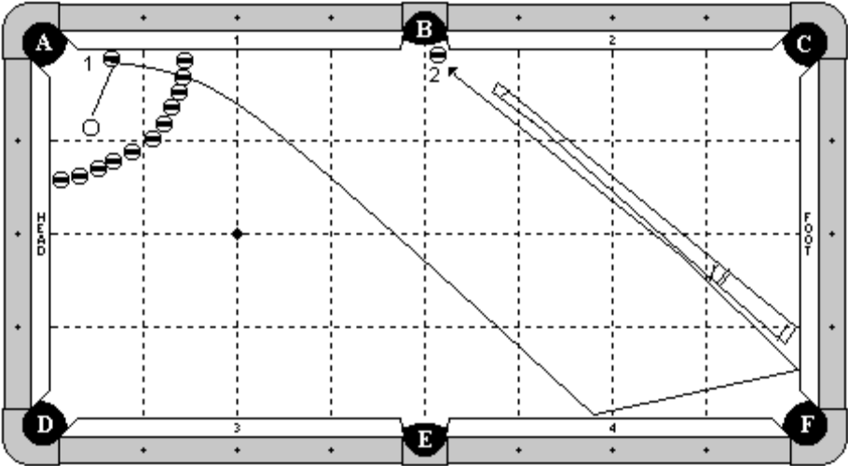

Cue Ball
In hand within circle of balls, at least two ball widths from cushion 1.
Object Balls
1 ball is frozen to cushion 1, within the circle of balls.
2 ball is hanging in pocket ‘B’.
A circle of blocking balls are placed as diagrammed, with the first and last balls at 1 ½ diamond segments.
A cue stick is placed so the butt end is frozen to the foot cushion at the 1st diamond from pocket ‘F’.
Objective
Shoot the cue ball into the 1 ball. The cue ball will jump over the blocking balls contacting cushion 4, foot cushion, the cue stick, and pocketing 2 ball in pocket ‘B’.
Special Notes
The cue ball does not have to contact the cue stick.
The cue ball may not contact the blocking balls.
The 1 ball may contact the blocking balls.

Discipline 7 – Shot 3a – 8 points - The Robin Dodson Jump

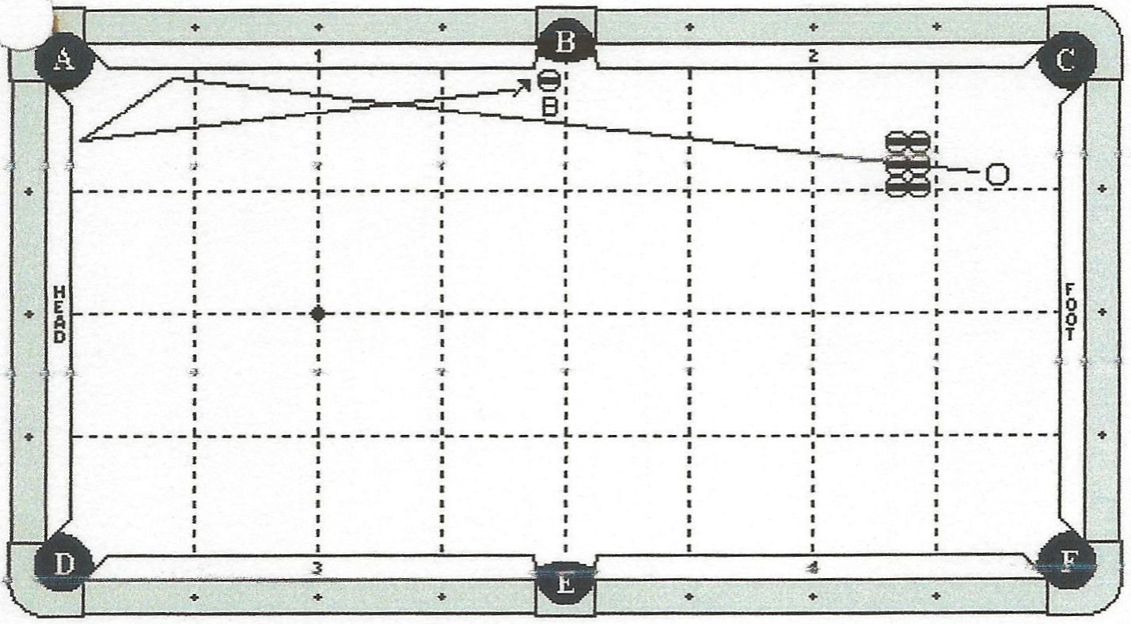

Cue Ball
In hand behind 1st diamond line.
Object Balls
6 object balls are in a 3x2 rectangle and may be positioned anywhere provided that it is directly in line with the path of the cue ball. Ball ‘B’ is hanging near pocket B.
Objective
Jump the cue ball over 6 blocking balls, finally making ‘B’ ball.
Special Notes
The cue ball may contact extra cushion near pocket B.

Discipline 7 – Shot 3b – 8 points - Yow’s Barrier

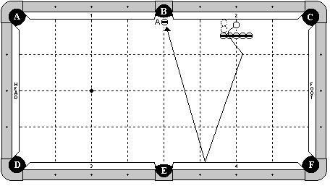

Cue Ball
In hand between the blocker balls and the cushion. The cue ball may not be adjusted left or right so that the edge passes the 2nd diamond line.
Object Balls
A row of 5 object balls are exactly 2 ball’s width off the cushion. The center ball is on the 2nd diamond line. ‘A’ ball is hanging near pocket ‘B’.
Objective
Jump the cue ball over the blocker balls, bank one rail, and make ‘A’ ball.
Special Notes
The blocker balls may not be touched by any means until after ‘A’ ball is made.

Discipline 7 – Shot 3c – 8 points - The Leap Frog Shot

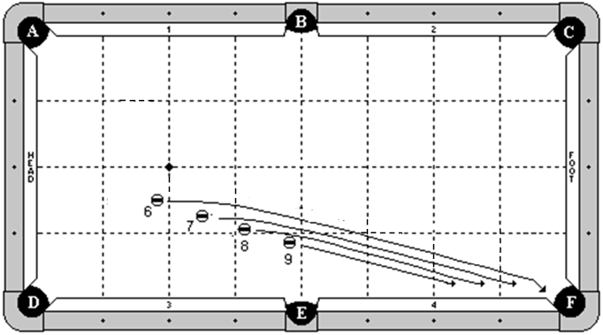

Cue Ball
None
Object Balls
The 6 through 9 balls are lined straight towards pocket ‘F’. They are in hand to the left of the B-E center line, but they must be all straight in line with each other and towards pocket ‘F’.
Objective
Jump the 6 ball, then the 7 ball, and finally the 8 ball. Each will be jumped into pocket ‘F’. Lastly, shoot the 9 ball straight into pocket ‘F’.
Special Notes
When jumping a ball, none of the other balls may be disturbed by any means.

Discipline 7 – Shot 4a – 9 points - Return to Sender

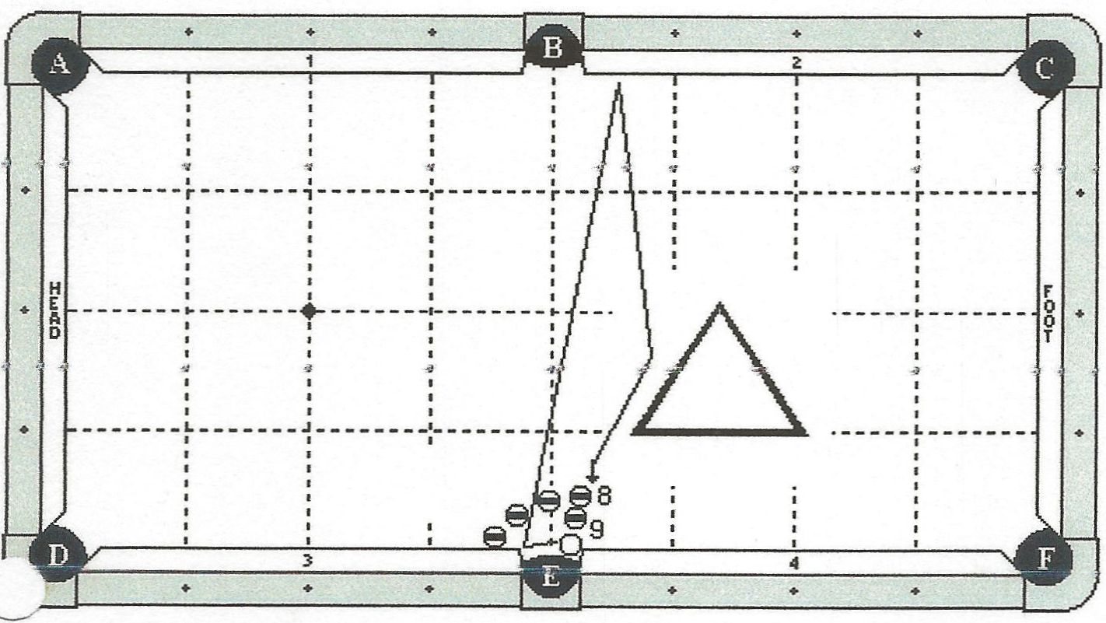

Cue Ball
Frozen to the side pocket point, and the vertical edge is aligned with the pocket cut.
Object Balls
Balls #8 and #9 are in hand, frozen near pocket E. Three blocking balls are placed in an arc, equally spaced from the cushion to ball #8 ( the first blocking ball is approximately 1 inch off the side pocket point). A rack is in hand.
Objective
Shoot the cue ball into the side pocket point, causing it to jump over the blocking balls, bank one rail, and make the 8-9 combination.
Special Notes
Only the 9 ball must be made. The cue ball may contact the rack (optional) before making the 9-ball. The combination must be made by the cue ball, not the rack. The blocking balls may not be touched by any means until after the 9-ball goes in. the cue ball must contact cushion 2 (not cushion 1).

Discipline 7 – Shot 4b – 9 points - The Evel Knievel Shot

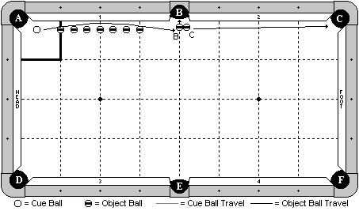

Cue Ball
In hand within the indicated zone, but must be directly in line with the other balls.
Object Balls
‘B’ and ‘C’ balls are as diagrammed near pocket ‘B’. They must be directly in line with the other balls. 7 blocker balls are in a straight line. The end balls are on the 1st and 3rd diamond lines, and the middle ball is on the 2nd diamond line. The blockers may not be more than 1 chalk’s width off the cushion. All balls, including the cue ball and the balls near pocket ‘B’ must be in a straight line.
Objective
Jump the cue ball over the line of blockers, and make ‘B’ ball in pocket ‘B’ and ‘C’ ball in pocket ‘C’.
Special Notes
The blocker balls may not be contacted by any means until after the cue ball has contacted ‘B’ ball.

Discipline 7 – Shot 4c – 9 points - The Railroad Shot

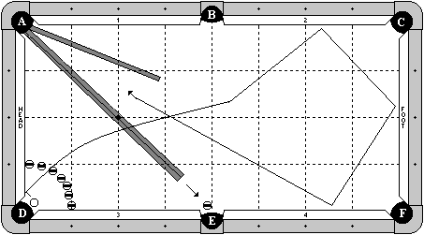

Cue Ball
In hand within the jaws of pocket ‘D’. It does not need to be frozen to the jaw, but the base may not be further out than the line between the pocket points.
Object Balls
7 blocker balls form a ring as diagrammed, with the first balls on either side frozen to the cushion at the 1st diamond. The other balls are spaced evenly. A ball is hanging near pocket ‘E’. Two regular cue sticks and one short stick form the classic ‘railroad’ formation as diagrammed.
Objective
Shoot the cue ball into the pocket point or the head cushion. The cue ball will jump over the ring of balls and over the sticks, travel 3 cushions as diagrammed, enter the ‘railroad’, go up the sticks, turn the corner, and come down the two regular sticks, to make the ball in pocket ‘E’.
Special Notes
The blocker balls may not be contacted by any means until after ‘E’ ball is made. The cue ball may contact the sticks when jumping over them, but the player may not readjust the sticks during the course of the shot. The player selecting this shot is required to supply the cue sticks.
During setup, players may not roll the cue ball on the cue sticks to test either the turn at the corner pocket or where the cue sticks are aimed. In doing so, it will count as an attempt.

Discipline 7 – Shot 5a – 10 points - Jump In ‘n’ Out

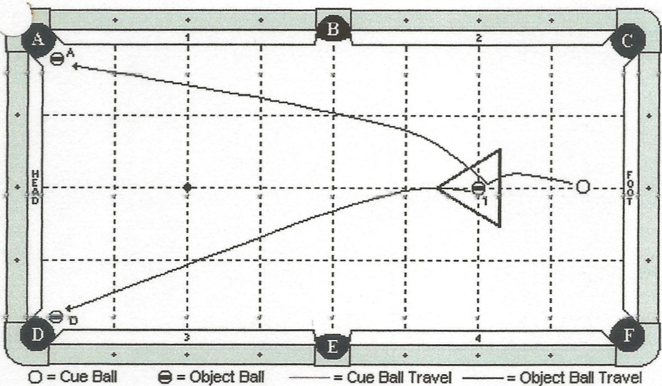

Cue Ball
In hand.
Object Balls
Object ball 1 is on the foot spot. The rack is in hand and is placed around object ball 1. ;A; and ;D; balls are hanging.
Objective
Jump the cue ball into object ball 1. Both balls will jump out of the rack. Object ball 1 will make ‘D’ ball and the cue ball will make ‘A’ ball.
Special Notes
Contact with the rack is okay. The player must designate which ball will be made by the cue ball and which ball will be made by the object ball in the rack.

Discipline 7 – Shot 5b – 10 points - The Six-Pack

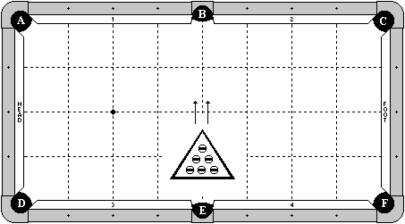

Cue Ball
None
Object Balls
6 object balls are in hand within a rack. A rack is placed centered on the B-E center line. The point of the rack may not pass the long center line of the table.
Objective
Using a 1-handed jacked up stroke, jump all object balls out of the rack, one at a time, into pocket ‘B’.
Special Notes
The rack may not be contacted by any means. When jumping a ball, no other ball may be disturbed.

Discipline 7 – Shot 5c – 10 points - The Derby Horse Race

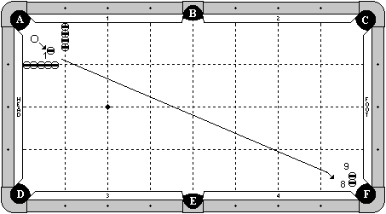

Cue Ball
In hand within the 1x1 diamond zone.
Object Balls
1 ball in hand within the 1x1 diamond zone. 8 ball is a special stacking ball near pocket ‘F’. 9 ball is balanced on top of it. 4 balls are frozen in line on the 1st diamond, with the first ball frozen to cushion 1. 5 balls are frozen in line on the 1st diamond, with the first ball frozen to the head cushion.
Objective
Shoot the cue ball into the 1 ball, causing it to roll towards the stacked balls. Re-hit the cue ball, jumping it over the 1 ball. The cue ball will make the 8 ball (bottom ball), and get of the way. The 1 ball will then make the 9 ball, which fell in place.
Special Notes
The cue ball, 1 ball, and stacked balls must all be in line. The blocker balls may not be contacted by any means until after the 8 ball is made. The 9 ball must be made by the 1 ball. It may not fall on its own or be made by the cue ball. After the initial contact between the cue ball and 1 ball, the 1 ball may not contact any other ball until it hits the 9 ball.

On a 7-ft table, only 3 blocker balls will be used on each diamond line.

DISCIPLINE

8

MASSE SHOTS

Discipline 8 – Shot 1a – 6 points - The Ultimate Trap Shot

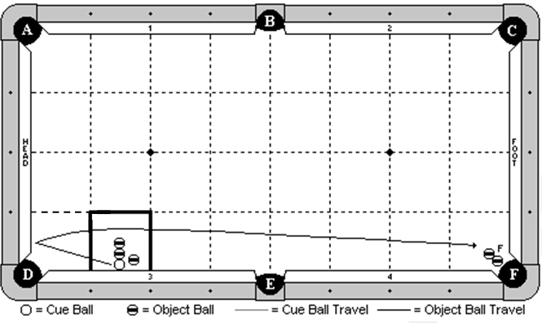

Cue Ball
Frozen to cushion 3 anywhere inside box zone.
Object Balls
Two object balls will be placed frozen in line with the cue ball (parallel to the head cushion). Another object ball will be placed ½ inch from cushion 3 and ½ inch from the cue ball. ‘F’ ball is hanging near pocket F and a ball will be placed frozen to it, creating dead combination. Edge of ‘F’ ball must be even with slate cut of pocket F.
Objective
Shoot the cue ball into cushion 3. It will bank into the head cushion, travel along the path indicated, making the ‘F’ ball.
Special Notes
The cue ball may not contact any of the blocking balls until after ‘F’ ball is made.

Discipline 8 – Shot 1b – 6 points - The Snake Shot

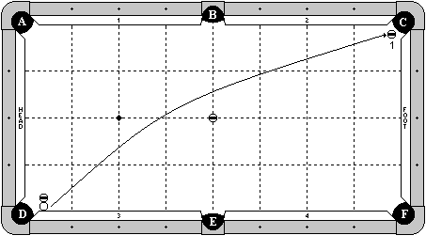

Cue Ball
Frozen to the cushion, with the edge aligned with the pocket point.
Object Balls
A blocker ball is frozen to the cue ball and perpendicular to cushion 3 (straight out). Another blocking ball is on the center point of the table. The 1 ball is hanging near pocket ‘C’.
Objective
Shoot the cue ball into cushion 3, compressing the rail and allowing the cue ball to escape. The cue ball will travel around the center blocking ball as diagrammed, and make the 1 ball.
Special Notes
Neither blocking ball may move by any means until after the 1 ball is made.

On a 7-ft table, the blocker ball will be moved 1 ball width towards the foot cushion. That is, the blocker ball will be placed frozen to the diagrammed blocker ball on the centerline towards the foot cushion, and then the diagrammed blocker ball will be removed.

Discipline 8 – Shot 1c – 6 points - The Escape Masse

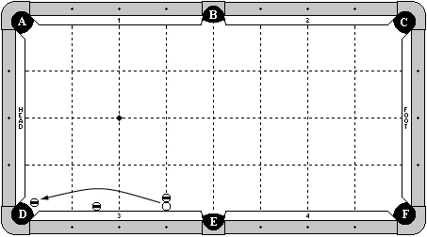

Cue Ball
Frozen to cushion 3 – one diamond from pocket ‘E’.
Object Balls
An object ball is hanging in pocket ‘D’.
One blocker ball is frozen to cue ball, directly in line along the diamond line. One blocker ball is frozen to cushion 3 at 1½-diamond segments from pocket ‘D’.
Objective
Masse the cue ball such that it escapes from between the blocking ball and rail and curves around the other blocking ball to make the object ball hanging in pocket ‘D’.
Special Notes
The blocking balls may not move by any means until the shot is complete.

Discipline 8 – Shot 2a – 7 points - “The Hustler” Masse Shot

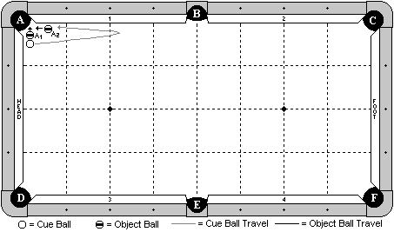

Cue Ball
In hand
Object Balls
Both object balls are in hand as diagrammed.
Objective
Execute a full masse, first making ‘A1’ ball, having the cue ball come out and back, and then making ‘A2’ ball. The cue ball may not come back by hitting the far pocket point of pocket ‘B’, nor may it come back by hitting any part of the foot cushion. The cue ball may contact cushion 1 or 2, but no other, until both balls have been made.
Special Notes
This is a masse shot. Players may not position the balls in such a way that they will both go in with a simple stroke. Players must elevate and make ‘A1’ ball first, then have the cue ball masse out and back to make ‘A2’ ball. This shot may be done from any corner, but it may not be rotated. In other words, ‘A2’ ball must be along cushions 1,2,3 or 4. It may not be along the head or foot cushion.

Discipline 8 – Shot 2b – 7 points - The Machine Gun Masse

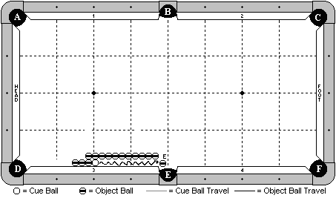

Cue Ball
Frozen to cushion 3 and to two other object balls next to it as diagrammed.
Object Balls
Three object balls are to the left of the cue ball, all frozen in line and to the cushion. 11 object balls are frozen in line exactly 1 ball’s width from cushion 3. The 11th ball is frozen to the object ball that is next to the cue ball. The 1st object ball in line may start anywhere to the left of the B-E center line. ‘E’ ball is hanging near pocket ‘E’ and is adjustable.
Objective
Masse the cue ball, causing the three balls to the left of the cue ball to move. The cue ball will masse back and finally make ‘E’ ball.
Special Notes
The cue ball must make ‘E’ ball, not another object ball. There is no requirement on how many balls must move, but players must setup the shot with the line of balls exactly 1 ball’s width off the cushion, and they must execute the shot with a full (or close to full) masse stroke.

Discipline 8 – Shot 2c – 7 points - Around the Rack Masse

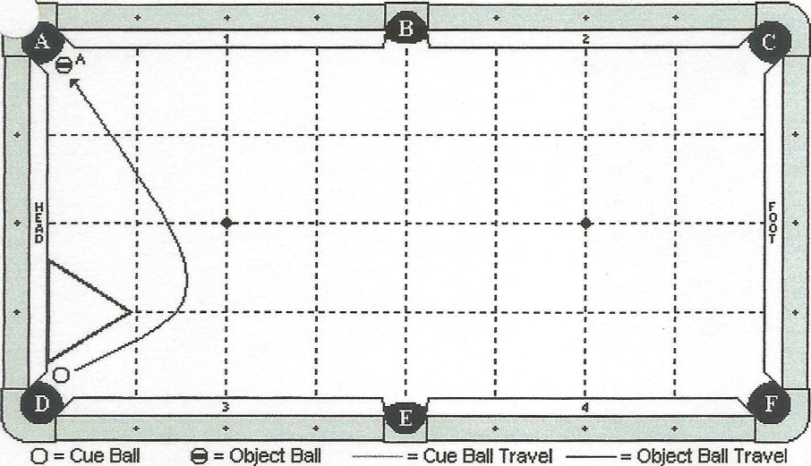

Cue Ball
In hand on pocket D side of rack, and may be no more than 1 ball’s width from head cushion.
Object Balls
‘A’ ball is hanging. Rack is placed against head cushion, with center of rack even with first diamond. If the rack has a lip, it will be placed up.
Objective
Masse the cue ball around the rack, making ‘A’ ball.
Special Notes
The rack may not be contacted by any means until after ‘A’ ball has been made. The cue ball may not contact cushion 3 or the foot cushion until after ‘A’ ball is made.

Discipline 8 – Shot 3a – 8 points - The Little Yo-Yo

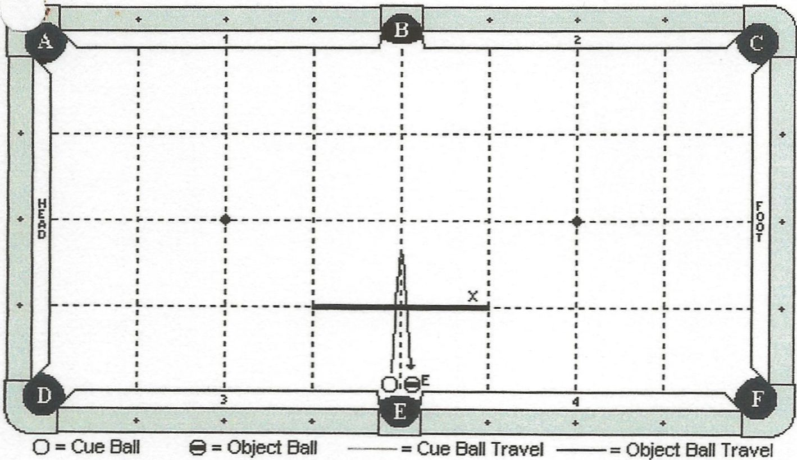

Cue Ball
In hand, no more than ½ ball’s width from slate cut of pocket E.
Object Balls
‘E’ ball is hanging.
Objective
Masse the cue ball past line ‘X’ and back, making ‘E’ ball.
Special Notes
The cue ball must completely pass line ‘X’ (trailing edge). The cue ball may not contact ‘E’ ball before passing line ‘X’. Cue ball may not contact cushions 1 or 2 until after ‘E’ ball is made.

Discipline 8 – Shot 3b – 8 points - The Mini Rocket Masse

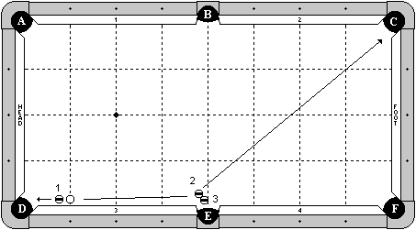

Cue Ball
On the first diamond line, no more than 1 chalk’s width from the cushion.
Object Balls
1 ball is in hand, but must be at least 1 chalk’s width from the cue ball. The 2 and 3 balls are in hand near pocket ‘E’.
Objective
Masse the cue ball, making the 1 ball in pocket ‘D’. The cue ball will masse back into the 2 ball, making it in pocket ‘C’ and making the 3 ball in pocket ‘E’.
Special Notes
Players must use a full masse stroke for this shot. They may not use a draw stoke.

Discipline 8 – Shot 3c – 8 points - The Big Guy Masse

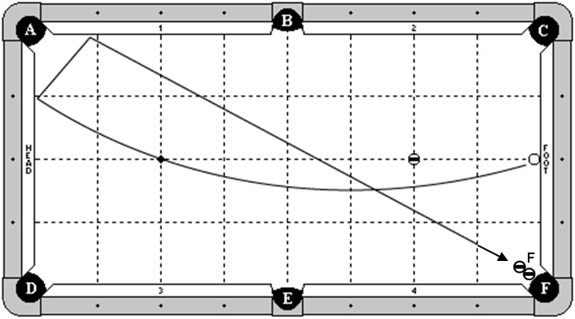

Cue Ball
Frozen to foot cushion at second diamond.
Object Ball
F ball combo is hanging in pocket ‘F’.
A blocker ball is on the foot spot.
Objective
Masse the cue ball around the blocking ball, hitting the head cushion and cushion 1, and making the F ball in pocket ‘F’.
Special Notes
The cue ball may contact an extra cushion by pocket ‘F’.
The blocker ball may not be contacted by any means until ‘F’ ball is pocketed.

Discipline 8 – Shot 4a – 9 points - The Jump Masse

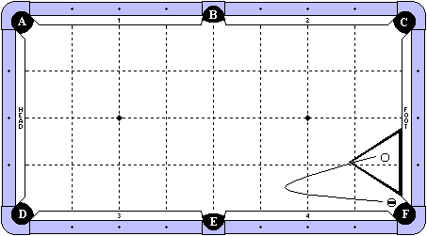

Cue Ball
In hand within the rack.
Object Balls
An object ball is hanging near pocket ‘F’. A rack is placed frozen to the foot cushion as diagrammed.
Objective
Hit the cue ball with a jump masse stroke. It will jump out of the rack, turn around and come back to make the object ball in pocket ‘F’.
Special Notes
The rack may not be touched when the cue ball is jumping out of it, but it may be contacted when the cue ball comes back to make the object ball. The cue ball’s trailing edge must completely pass the 2nd diamond line. Decision by the referee is final. The cue ball may contact cushion 3 or 4, but none other until ‘F’ ball is made. The cue ball may not come back because it hit the far pocket point of pocket ‘E’. Decision by the referee is final.

Discipline 8 – Shot 4b – 9 points - The Big Rocket Masse

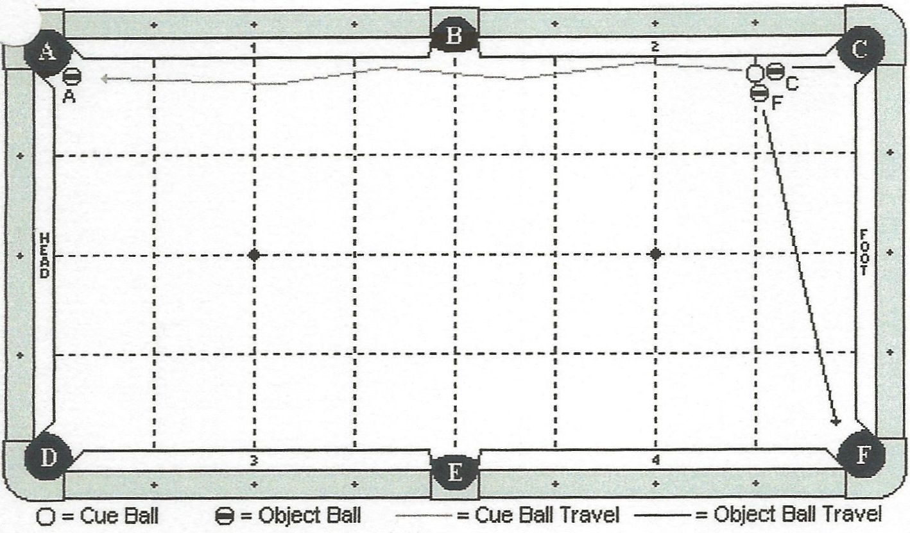

Cue Ball
Along 1 diamond line, no more than 1 inch from the long rail.
Object Balls
‘C’ and ‘F’ balls are in hand, but may not be closer than ¼ inch from the cue ball. ‘A’ ball is hanging near pocket A.
Objective
Hit the cue ball with a masse stroke, making ‘C’ and ‘F’ balls in their respective pockets. The cue ball will masse down the rail, contacting it at least once, and making ‘A’ ball.
Special Notes
None.

Discipline 8 – Shot 4c – 9 points - The Rebound Masse

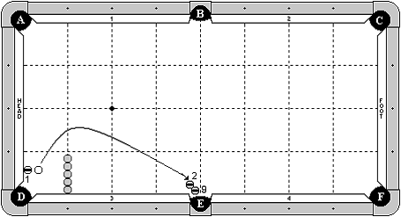

Cue Ball
In hand, but may not be frozen to 1 ball.
Object Balls
1 ball is frozen to the head cushion, ½ diamond from pocket ‘D’.
2 and 3 balls form a combination by pocket ‘E’.
Five blocker balls are frozen in a line off of rail 3, one diamond segment from pocket ‘D’.
Objective
Shoot the cue ball into 1 ball. The cue ball will carom around the blocker balls and masse back to make the 3 ball in pocket ‘E’.
Special Notes
The cue ball may not touch the blocker balls until 3 ball is made.
The 1 ball may contact the blocker balls.
The cue ball may contact the 2 or 3 ball first, so long as the 3 ball is pocketed.

Discipline 8 – Shot 5a – 10 points - The Rail Kick Masse

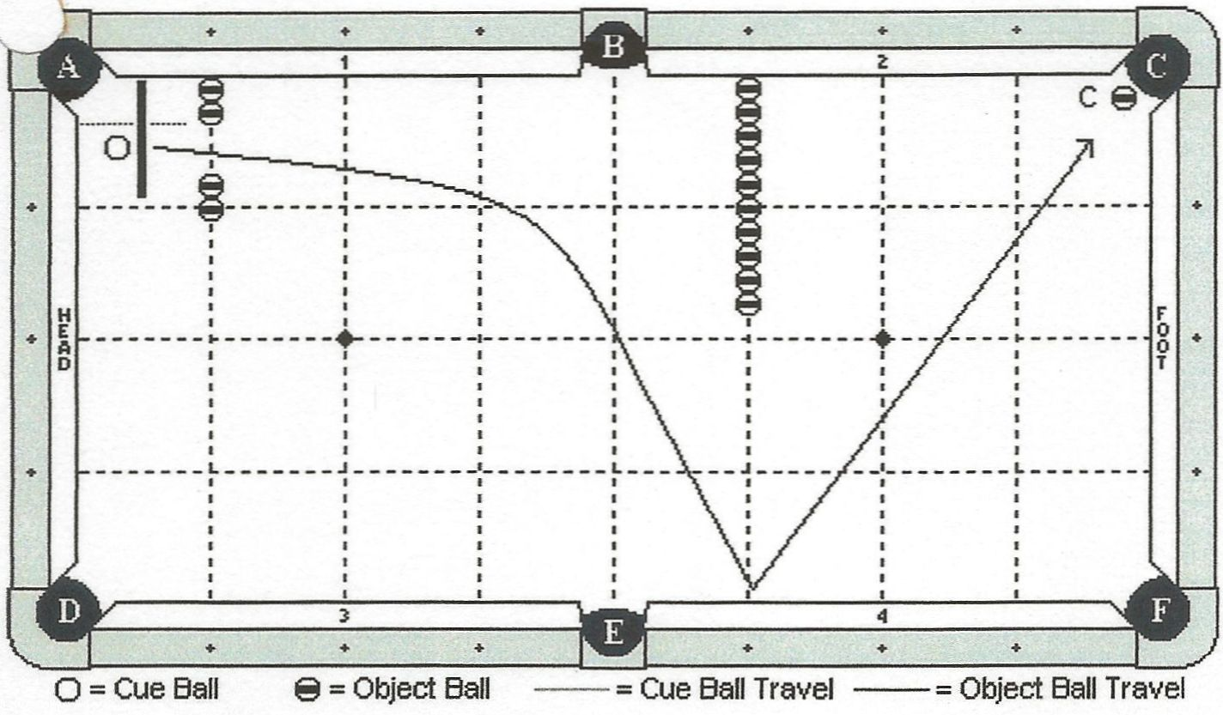

Cue Ball
In hand behind the ½ diamond line indicated by the diagram. The base of the cue ball may not be placed past the edge of the 2nd blocking ball (indicated by a dotted line).
Object Balls
Four blocking balls are positioned on the 1st diamond line, with a 2 ball gap between the 2nd and the 3rd ball. 10 blocking balls are on the 3rd diamond line and are all frozen to each other, with the first ball frozen to the cushion. ‘C’ ball is hanging near pocket C.
Objective
Masse the cue ball through the gap, following the path indicated by the diagram, making ‘C’ ball.
Special Notes
Cue ball may contact extra cushion near pocket C. Blocking balls may not be touched until after ‘C’ ball is made.

Discipline 8 – Shot 5b – 10 points - The Minguad Masse

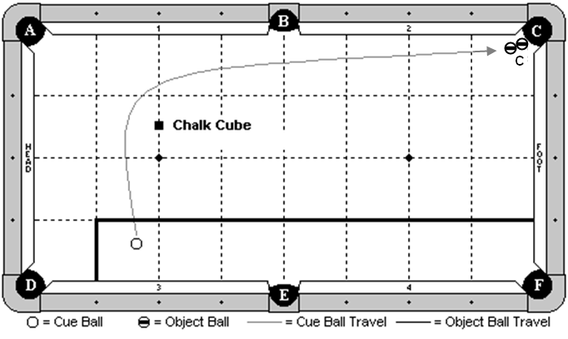

Cue Ball
In hand within the indicated zone.
Object Balls
‘C’ ball combo is at pocket C. A piece of chalk is placed square to the table along the head string, exactly 1 ½ diamonds from cushion 1.
Objective
Masse the cue ball around the chalk, along the indicated path, and make ‘C’ ball combo.
Special Notes
The chalk may not be contacted by any means until after ‘C’ ball is made. The cue ball may not contact the head cushion until after ‘C’ ball is made.

Discipline 8 – Shot 5c – 10 points - The Yow Masse

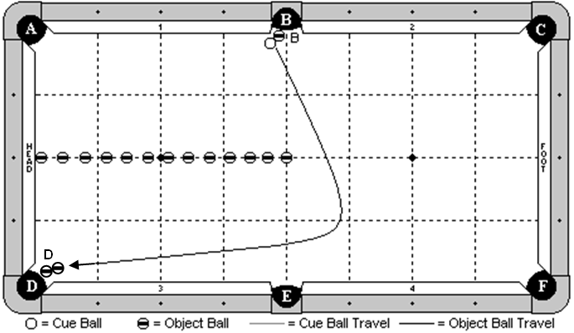

Cue Ball
In hand, frozen to ‘B’ ball.
Object Balls
‘B’ ball is in hand near pocket ‘B’, but must be to the left of the B-E center line. ‘D’ ball combo is hanging near pocket ‘D’. 13 blocker balls are placed along the long center line of the table. The first ball is frozen to the head cushion. The last ball is on the exact center spot of the table. The other balls are evenly spaced.
Objective
Masse the cue ball, making ‘B’ ball. The cue ball will travel around the blocker balls as diagrammed, and make ‘D’ ball combo.
Special Notes
The blocker balls may not be touched by any means until after ‘D’ ball is made.

Tiebreaker Shot / Challenge

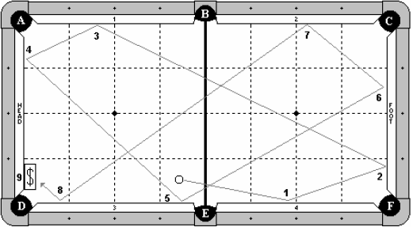

Cue Ball
The cue ball is in hand and anywhere behind centerline (‘B’ – ‘E’).
Object Balls
No object balls are in this challenge. A dollar bill is placed on the table so that its edge is even with the head cushion nose. The center of bill is halfway between pocket ‘D’ and the 1st diamond from pocket ‘D’.
Objective
Tied players will get 1 attempt to shoot the cue ball 8 or 9 cushions in diagram pattern to dollar bill. The player that lands his or her cue ball closest to the center of the dollar bill wins this challenge. Table judge decision is final.
Special Notes
Tied players will lag to determine who goes first. Winner of lag has choice of shooting first or last.
Cue ball must contact either the 8 or the 9 cushions. Contact with one is required. Contact with both is optional. In other words, an exception to the diagramed cue ball travel may result if the head cushion is hit as the 8th cushion and the #3 cushion is not hit near pocket D. In addition, cue ball may hit cushion #4 as the 5th cushion hit.
The vertical edge of the cue ball closest to the dollar bill center will determine the “measured” distance for comparing all player rolls.
If none of the tied players hits 8 or 9 cushions, then the shot will be done over with another lag between the tied players to see who goes 1st with the lag winner having choice again of shooting first or last.

